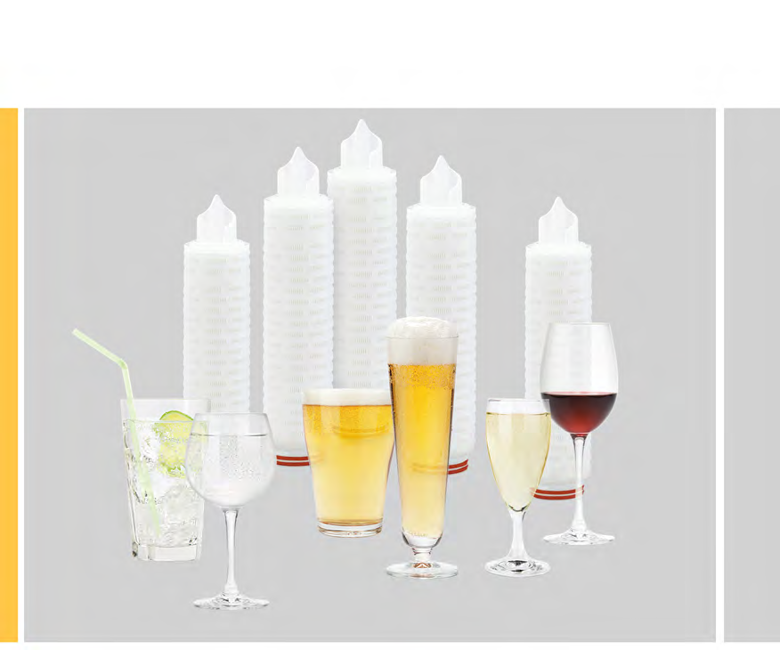
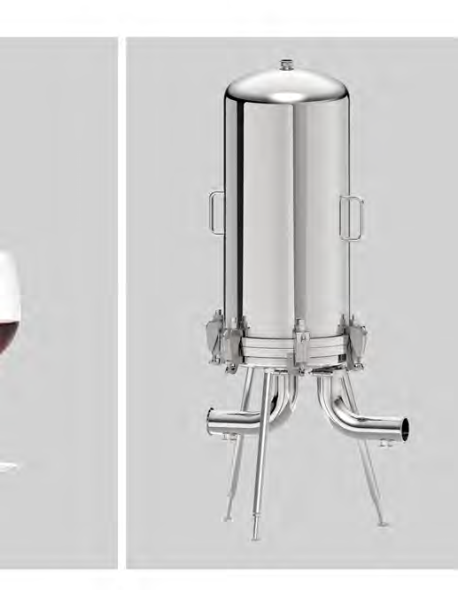

Food u Beverage Catalogue Stainless Steel - Filter Housings

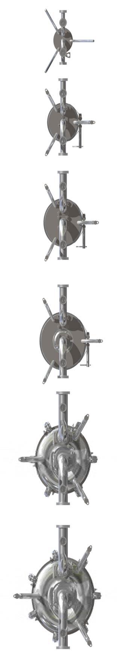
Introduction

Sartorius Stedim Biotech FuB filter housings were developed for sanitary beverage filtration applications, including:

- Beer
- Wine u spirits
- Mineral | Bottled water
- Carbonated Soft drinks
- Non-carbonated Soft drinks

Thanks to their optimized design, our FuB housings are exceptionally easy to clean for thorough results and can be in-line steam sterilized as a complete unit, incl. gaskets.

Our housings have been designed in accordance with the European Pressure Equipment Directive PED 2014/68/EU - rule EN13445.

The complete series of 810 and 813 housings are available in sizes ranging from 1 to 30 cartridges and heights from 10“ to 40“.

The cartridge socket adapter is available in code 25 (code 7) and code 28 (810 liquid u 813 liquid).

Sartorius Stedim Biotech FuB housings can be equipped with
a wide range of Inlet and Outlet connections such as DIN11851 and sanitary Clamp. Other connections are available upon request. Vent and drain options are also available in multiple designs and configurations.

Gaskets are offered in various material types depending on
the application. As standard, we use FDA, USP Class VI, EC 1935/2004 arti- cle 3 - u Phthalate-free compliant Silicone u EPDM
elastomers.

Certification is according to PED 2014/68/EU. Additional certificates like Ra roughness or material certificates (MTR‘s) are available upon request.

Only 316L grade stainless steel is used for all wetted surfaces to provide maximum durability and resistance to corrosion.

Contents Directory
Introduction | 2
Description | 3
Contents Directory | 4
Type 810 (10 bar Version)
Standard Liquid Housing T-Type - Series VHP
1-round – incl. Spare Parts | 6 - 9
3-round – incl. Spare Parts | 10 - 13
5-round – incl. Spare Parts | 14 - 17
8-round – incl. Spare Parts | 18 - 21
12-round – incl. Spare Parts | 22 - 25
18-round – incl. Spare Parts | 26 - 29
24-round – incl. Spare Parts | 30 - 34
30-round – incl. Spare Parts | 35 - 38
36-round – incl. Spare Parts | 39 - 40
Type 810 Fluid group 1 (dangerous)
Standard Liquid Housing T-Type - Series SH
1-round – incl. Spare Parts 3-round – incl. Spare Parts | 41 - 45  46 - 49
5-round – incl. Spare Parts | 50 - 53
8-round – incl. Spare Parts | 54 - 57
12-round – incl. Spare Parts | 58 - 61
18-round – incl. Spare Parts | 62 - 65
24-round – incl. Spare Parts | 66 - 69
30-round – incl. Spare Parts | 70 - 73

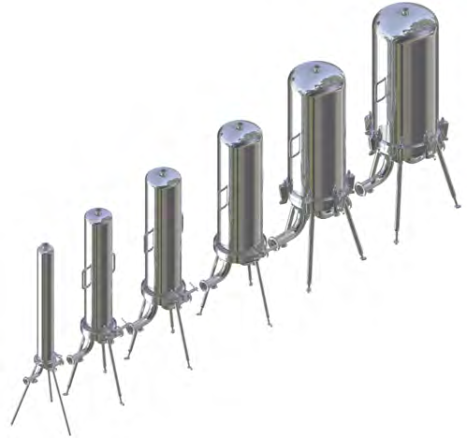
Standard Liquid Housing In-Line - Series ALN
- round 74 - 75
Standard 1-round Gas Housing - Series KMC 76
- round 77 - 80
Type 805 (5 bar Version) 81
Standard Multi-round Gas Housing - Series AIR 82 - 84
3- | 5- | 8-round
Type 808 (8 bar Version) 85
Industrial - 1-round - liquid housing - Series FI 86 - 87
Type 800 (Pressureless) 88
Vent Housings - Series VSN
1- | 3- | 5- | 8-round 89 - 91
Jumbo 1-round (Sartorius) 92

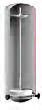
Overview of housing types

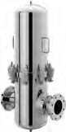
Type 800 - Vent Housings - pressureless Cartridge number: 01 | 03 | 05 | 08

Type 805 - Gas Housings (Multi-round) - 5bar Cartridge number: 03 | 05 | 08

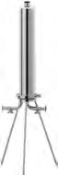
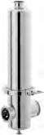
Type 810 - Gas Housing* | Liquid Housings - 10 bar Cartridge number: 01 | 03 | 05 | 08

*Gas Housings 10 bar only available in 1-round

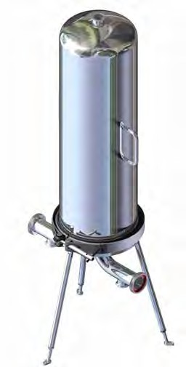
Type 813 13 bar Version

Working pressure: max.13 bar | 189 psi Temperature: max. 40°C | 104°F

Working pressure: max.4 bar | 58 psi Temperature: max. 150°C | 302°F

Cartridge adapter 25 | Code 7

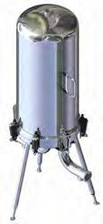
Internal surface roughness: Ra<0.8μm | 32μin External surface roughness Ra<1.6μm | 64 μin Mechanically polished

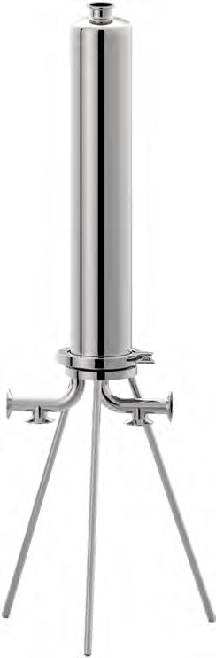
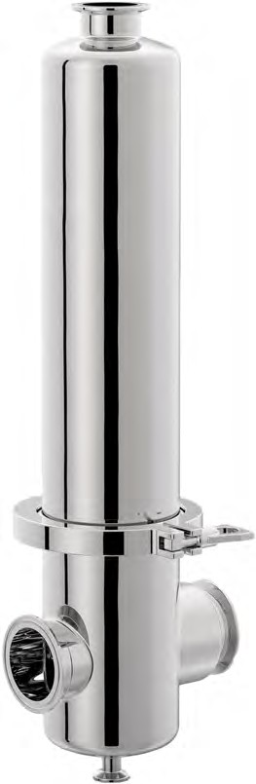
Type 810

(10 bar Version)

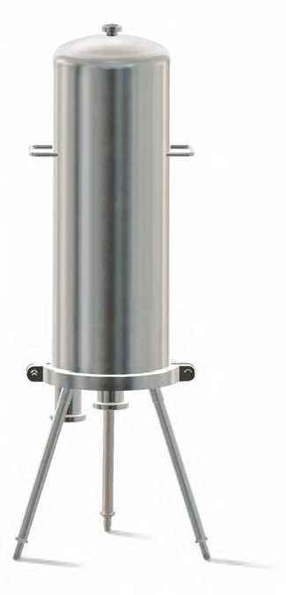
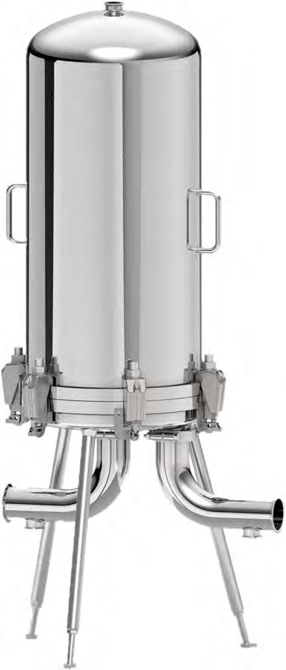
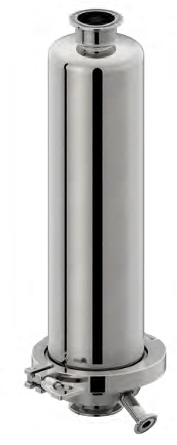

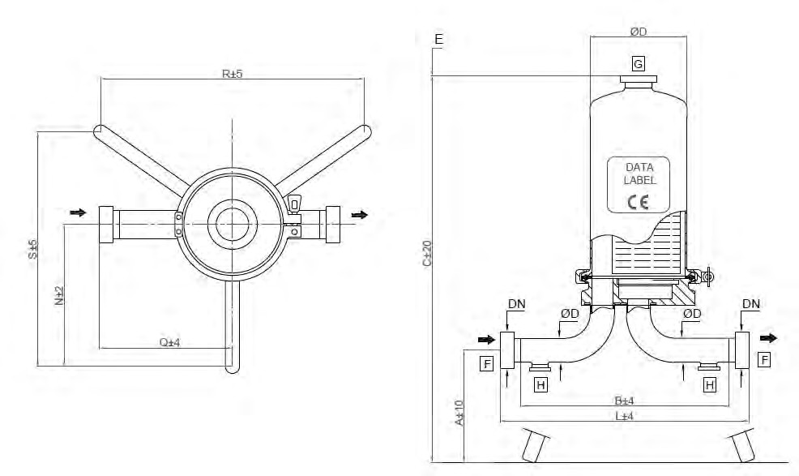

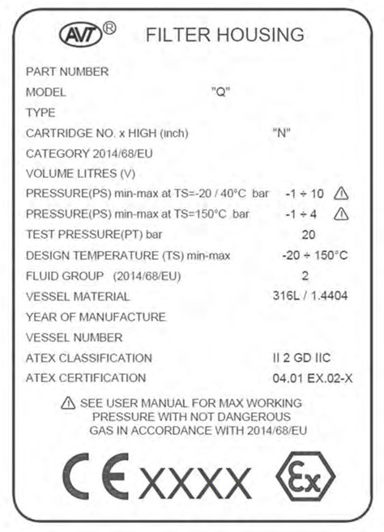
Fluid group 1 (dangerous) on request
article no., price u delivery time can be different.

DIMENSIONAL DATA
CARTRIDGE x HEIGHT (N) | R mm | S mm | N mm | C mm | E mm | VOLUME liters (V) | PED Category
01 x 10“ | 360 | 312 | 208 | 790 | 300 | 3.0 | 4.3
01 x 20“ | 360 | 312 | 208 | 1040 | 550 | 4.8 | 4.3
01 x 30“ | 360 | 312 | 208 | 1290 | 800 | 6.8 | I
01 x 40“ | 360 | 312 | 208 | 1540 | 1050 | 8.6 | I

CLAMP
 | WITHOUT DRAIN |  |  | WITH DRAIN
Dimension [mm] | A | L | Q | A | L | Q
1.0“ (25.4mm x 1.65mm) | 381 | 188 | 103 | 381 | 269 | 154

DIN 11851 MALE PART
 | WITHOUT DRAIN |  |  | WITH DRAIN
Dimension [mm] | A | L | Q | A | L | Q
DN25 | 381 | 220 | 118 | 381 | 300 | 169

BUTT WELD ASME BPE
 | WITHOUT DRAIN |  |  | WITH DRAIN
Dimension [mm] | A | B | Q | A | B | Q
1.0“ (25.4mm x 1.65mm) | 381 | 163 | 90 | 381 | 244 | 141

PACKAGING SIZE AND WEIGHT
CARTRIDGE x HEIGHT (N) | BOWL WEIGHT [kg] | TOTAL NET WEIGHT [kg] | PACKAGING SIZE [cm] | TOTAL WEIGHT PACKED [kg]
01 x 10“ | 2.0 | 7.0 | 65x27x17 | 8.0
01 x 20“ | 3.3 | 8.2 | 87x27x17 | 9.5
01 x 30“ | 4.6 | 9.4 | 112x27x17 | 11.0
01 x 40“ | 5.9 | 10.6 | 137x27x17 | 13.0

ORDER CODE AND TECHNICAL EQUIPMENT
Order-no. | No. of Cartridges | Bowl Height | Connection | Nominal Diameter | Gasket | With Vent TC 1.5“ | With Drain TC 1.0“
 | 01 | 10“ | DIN 11851 Male Part | DN 25 | Silicone | x | x
 | 01 | 10“ | DIN 11851 Male Part | DN 25 | EPDM | x | x
 | 01 | 10“ | DIN 11851 Male Part | DN 25 | Silicone | x | -
 | 01 | 10“ | DIN 11851 Male Part | DN 25 | EPDM | X | -
 | 01 | 10“ | TC | 1“ | Silicone | x | x
 | 01 | 10“ | TC | 1“ | EPDM | x | x
 | 01 | 10“ | TC | 1“ | Silicone | x | -
 | 01 | 10“ | TC | 1“ | EPDM | x | -
 | 01 | 10“ | Welding Stubs | 25.4 x 1.65 | Silicone | x | x
 | 01 | 10“ | Welding Stubs | 25.4 x 1.65 | EPDM | x | x
 | 01 | 10“ | Welding Stubs | 25.4 x 1.65 | Silicone | x | -
 | 01 | 10“ | Welding Stubs | 25.4 x 1.65 | EPDM | x | -
 | 01 | 20“ | DIN 11851 Male Part | DN 25 | Silicone | x | x
 | 01 | 20“ | DIN 11851 Male Part | DN 25 | EPDM | x | x
 | 01 | 20“ | DIN 11851 Male Part | DN 25 | Silicone | x | -
 | 01 | 20“ | DIN 11851 Male Part | DN 25 | EPDM | x | -
 | 01 | 20“ | TC | 1“ | Silicone | x | x
 | 01 | 20“ | TC | 1“ | EPDM | x | x
 | 01 | 20“ | TC | 1“ | Silicone | x | -
 | 01 | 20“ | TC | 1“ | EPDM | x | -
 | 01 | 20“ | Welding Stubs | 25.4 x 1.65 | Silicone | x | x
 | 01 | 20“ | Welding Stubs | 25.4 x 1.65 | EPDM | x | x
 | 01 | 20“ | Welding Stubs | 25.4 x 1.65 | Silicone | x | -
 | 01 | 20“ | Welding Stubs | 25.4 x 1.65 | EPDM | x | -
 | 01 | 30“ | DIN 11851 Male Part | DN 25 | Silicone | x | x
 | 01 | 30“ | DIN 11851 Male Part | DN 25 | EPDM | x | x
 | 01 | 30“ | DIN 11851 Male Part | DN 25 | Silicone | x | -
 | 01 | 30“ | DIN 11851 Male Part | DN 25 | EPDM | x | -
 | 01 | 30“ | TC | 1“ | Silicone | x | x
 | 01 | 30“ | TC | 1“ | EPDM | x | x
 | 01 | 30“ | TC | 1“ | Silicone | x | -
 | 01 | 30“ | TC | 1“ | EPDM | x | -
 | 01 | 30“ | Welding Stubs | 25.4 x 1.65 | Silicone | x | x
 | 01 | 30“ | Welding Stubs | 25.4 x 1.65 | EPDM | x | x
 | 01 | 30“ | Welding Stubs | 25.4 x 1.65 | Silicone | x | -
 | 01 | 30“ | Welding Stubs | 25.4 x 1.65 | EPDM | x | -
 | 01 | 40“ | DIN 11851 Male Part | DN 25 | Silicone | x | x
 | 01 | 40“ | DIN 11851 Male Part | DN 25 | EPDM | x | x
 | 01 | 40“ | DIN 11851 Male Part | DN 25 | Silicone | x | -
 | 01 | 40“ | DIN 11851 Male Part | DN 25 | EPDM | x | -
 | 01 | 40“ | TC | 1“ | Silicone | x | x
 | 01 | 40“ | TC | 1“ | EPDM | x | x
 | 01 | 40“ | TC | 1“ | Silicone | x | -
 | 01 | 40“ | TC | 1“ | EPDM | x | -
 | 01 | 40“ | Welding Stubs | 25.4 x 1.65 | Silicone | x | x
 | 01 | 40“ | Welding Stubs | 25.4 x 1.65 | EPDM | x | x
 | 01 | 40“ | Welding Stubs | 25.4 x 1.65 | Silicone | x | -
 | 01 | 40“ | Welding Stubs | 25.4 x 1.65 | EPDM | x | -
XX = 25 (Adapter 25 / code 7) 8
XX = 28 (Sartorius Adapter 28 tripple Bayonet)

SPARE PARTS
POS. | DESCRIPTION | MATERIAL | PART NO. | Q.TY
1 | HOUSING BOWL | AISI 316L |  | 1
2 | CLAMP 4“ | AISI 304 |  | 1
3a | CLAMP | AISI 316L |  | 1
3 | CARFTRIDGES PLATE + BENDS | AISI 316L |  | 1
4 | GASKET CLAMP 4“ | SILICONE |  | 1
4 | GASKET CLAMP 4“ | EPDM |  | 1
5 | LEG | AISI 304 |  | 3
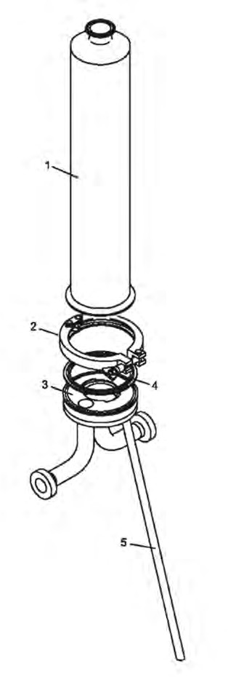

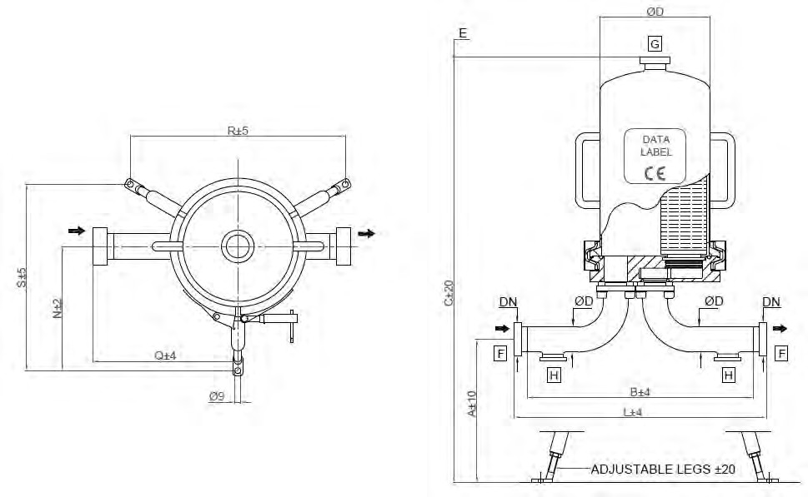

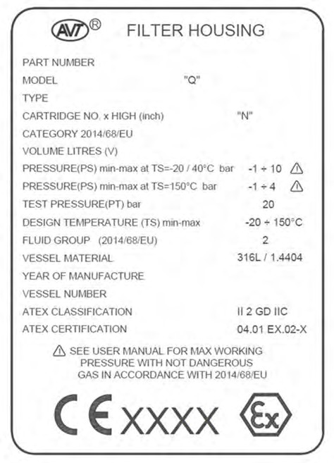
Fluid group 1 (dangerous) on request
article no., price u delivery time can be different.

DIMENSIONAL DATA
CARTRIDGE x HEIGHT (N) | R mm | S mm | N mm | C mm | E mm | VOLUME liters (V) | PED Category
03 x 10“ | 357 | 310 | 206 | 816 | 290 | 7.3 | I
03 x 20“ | 357 | 310 | 206 | 1065 | 540 | 12.6 | I
03 x 30“ | 357 | 310 | 206 | 1314 | 790 | 17.8 | I
03 x 40“ | 357 | 310 | 206 | 1564 | 1040 | 23.1 | II

CLAMP
 | WITHOUT DRAIN |  |  | WITH DRAIN
Dimension [mm] | A | L | Q | A | L | Q
1.5“ (38.1mm x 1.65mm) | 345 | 310 | 147 | 345 | 385 | 223

DIN 11851 MALE PART
 | WITHOUT DRAIN |  |  | WITH DRAIN
Dimension [mm] | A | L | Q | A | L | Q
DN40 | 345 | 351 | 168 | 345 | 426 | 243

BUTT WELD ASME BPE
 | WITHOUT DRAIN |  |  | WITH DRAIN
Dimension [mm] | A | B | Q | A | B | Q
1.5“ (38.1mm x 1.65mm) | 345 | 285 | 135 | 345 | 360 | 210

PACKAGING SIZE AND WEIGHT
CARTRIDGE x HEIGHT (N) | BOWL WEIGHT [kg] | TOTAL NET WEIGHT [kg] | PACKAGING SIZE [cm] | TOTAL WEIGHT PACKED [kg]
03 x 10“ | 4.0 | 17.4 | 80x30x37 | 23.0
03 x 20“ | 6.0 | 19.4 | 104x30x37 | 25.0
03 x 30“ | 8.0 | 21.4 | 130x30x37 | 27.0
03 x 40“ | 10.0 | 23.4 | 155x30x37 | 29.0

Please Note
In filter housings with a flange connection at the in- and outlet e.g. DIN-EN1092-1, ANSI, etc. the bends will be welded directly to the baseplate, instead of the standard flange connection described in the detailed drawing.

ORDER CODE AND TECHNICAL EQUIPMENT
Order-no. | No. of Cartridges | Bowl Height | Connection | Nominal Diameter | Gasket | With Vent TC 1.5“ | With Drain TC 1.5“
 | 03 | 20“ | DIN 11851 Male Part | DN 40 | Silicone | x | x
 | 03 | 20“ | DIN 11851 Male Part | DN 40 | EPDM | x | x
 | 03 | 20“ | DIN 11851 Male Part | DN 40 | Silicone | x | -
 | 03 | 20“ | DIN 11851 Male Part | DN 40 | EPDM | x | -
 | 03 | 20“ | TC | 1.5“ | Silicone | x | x
 | 03 | 20“ | TC | 1.5“ | EPDM | x | x
 | 03 | 20“ | TC | 1.5“ | Silicone | x | -
 | 03 | 20“ | TC | 1.5“ | EPDM | x | -
 | 03 | 20“ | Welding Stubs | 38.1 x 1.65 | Silicone | x | x
 | 03 | 20“ | Welding Stubs | 38.1 x 1.65 | EPDM | x | x
 | 03 | 20“ | Welding Stubs | 38.1 x 1.65 | Silicone | x | -
 | 03 | 20“ | Welding Stubs | 38.1 x 1.65 | EPDM | x | -
 | 03 | 30“ | DIN 11851 Male Part | DN 40 | Silicone | x | x
 | 03 | 30“ | DIN 11851 Male Part | DN 40 | EPDM | x | x
 | 03 | 30“ | DIN 11851 Male Part | DN 40 | Silicone | x | -
 | 03 | 30“ | DIN 11851 Male Part | DN 40 | EPDM | x | -
 | 03 | 30“ | TC | 1.5“ | Silicone | x | x
 | 03 | 30“ | TC | 1.5“ | EPDM | x | x
 | 03 | 30“ | TC | 1.5“ | Silicone | x | -
 | 03 | 30“ | TC | 1.5“ | EPDM | x | -
 | 03 | 30“ | Welding Stubs | 38.1 x 1.65 | Silicone | x | x
 | 03 | 30“ | Welding Stubs | 38.1 x 1.65 | EPDM | x | x
 | 03 | 30“ | Welding Stubs | 38.1 x 1.65 | Silicone | x | -
 | 03 | 30“ | Welding Stubs | 38.1 x 1.65 | EPDM | x | -
 | 03 | 40“ | DIN 11851 Male Part | DN 40 | Silicone | x | x
 | 03 | 40“ | DIN 11851 Male Part | DN 40 | EPDM | x | x
 | 03 | 40“ | DIN 11851 Male Part | DN 40 | Silicone | x | -
 | 03 | 40“ | DIN 11851 Male Part | DN 40 | EPDM | x | -
 | 03 | 40“ | TC | 1.5“ | Silicone | x | x
 | 03 | 40“ | TC | 1.5“ | EPDM | x | x
 | 03 | 40“ | TC | 1.5“ | Silicone | x | -
 | 03 | 40“ | TC | 1.5“ | EPDM | x | -
 | 03 | 40“ | Welding Stubs | 38.1 x 1.65 | Silicone | x | x
 | 03 | 40“ | Welding Stubs | 38.1 x 1.65 | EPDM | x | x
 | 03 | 40“ | Welding Stubs | 38.1 x 1.65 | Silicone | x | -
 | 03 | 40“ | Welding Stubs | 38.1 x 1.65 | EPDM | x | -

XX = 25 (Adapter 25 / code 7) 12
XX = 28 (Sartorius Adapter 28 tripple Bayonet)

SPARE PARTS
POS. | DESCRIPTION | MATERIAL | PART NO. | Q.TY
1 | HOUSING BOWL | AISI 316L |  | 1
2 | V-BAND | AISI 304 |  | 1
3 | CARTRIDGE PLATE | AISI 316L |  | 1
4 | O-RING d=5.35 ID=158.11 | SILICONE |  | 1
5 | GASKET CLAMP 1.5“ | PTFE |  | 2
6 | BEND FLANGE | AISI 304 |  | 4
7 | INLET BEND | AISI 316L |  | 1
8 | OUTLET BEND | AISI 316L |  | 1
9 | COMPLETE LEG | AISI 304 |  | 3
11 | PROTECTION PLATE | AISI 316L |  | 1

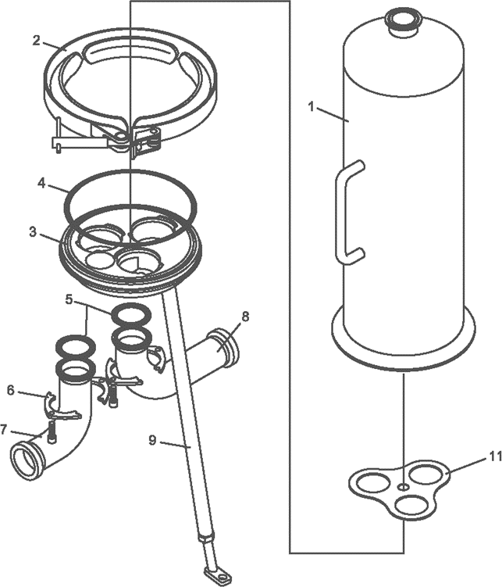

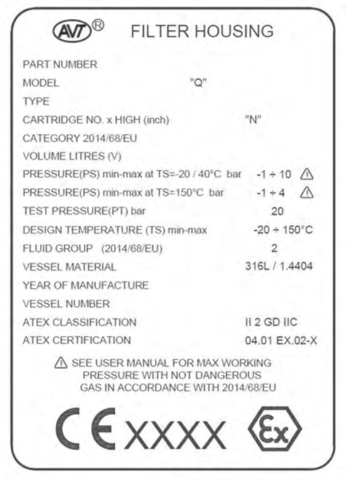
Fluid group 1 (dangerous) on request
article no., price u delivery time can be different.

DIMENSIONAL DATA
CARTRIDGE x HEIGHT (N) | R mm | S mm | N mm | C mm | E mm | VOLUME liters (V) | PED Category
05 x 10“ | 400 | 347 | 231 | 825 | 290 | 11 | I
05 x 20“ | 400 | 347 | 231 | 1075 | 540 | 20 | II
05 x 30“ | 400 | 347 | 231 | 1325 | 790 | 29.1 | II
05 x 40“ | 400 | 347 | 231 | 1575 | 1040 | 38.2 | II

CLAMP
 | WITHOUT DRAIN |  |  | WITH DRAIN
Dimension [mm] | A | L | Q | A | L | Q
2.0“ (50.8mm x 1.65mm) | 315 | 378 | 196 | 315 | 445 | 263

DIN 11851 MALE PART
 | WITHOUT DRAIN |  |  | WITH DRAIN
Dimension [mm] | A | L | Q | A | L | Q
DN50 | 315 | 423 | 218 | 315 | 490 | 285

BUTT WELD ASME BPE
 | WITHOUT DRAIN |  |  | WITH DRAIN
Dimension [mm] | A | B | Q | A | B | Q
2.0“ (50.8mm x 1.65mm) | 315 | 353 | 183 | 315 | 420 | 250

PACKAGING SIZE AND WEIGHT
CARTRIDGE x HEIGHT (N) | BOWL WEIGHT [kg] | TOTAL NET WEIGHT [kg] | PACKAGING SIZE [cm] | TOTAL WEIGHT PACKED [kg]
05 x 10“ | 5.3 | 11.0 | 72x35x37 | 24.0
05 x 20“ | 7.5 | 20.0 | 97x35x37 | 26.0
05 x 30“ | 10.2 | 22.0 | 122x35x37 | 28.0
05 x 40“ | 12.9 | 24.0 | 147x35x37 | 30.0

Please Note
In filter housings with a flange connection at the in- and outlet e.g. DIN-EN1092-1, ANSI, etc. the bends will be welded directly to the baseplate, instead of the standard flange connection described in the detailed drawing.

ORDER CODE AND TECHNICAL EQUIPMENT
Order-no. | No. of Cartridges | Bowl Height | Connection | Nominal Diameter | Gasket | With Vent TC 1.5“ | With Drain TC 1.5“
 | 05 | 20“ | DIN 11851 Male Part | DN 50 | Silicone | x | x
 | 05 | 20“ | DIN 11851 Male Part | DN 50 | EPDM | x | x
 | 05 | 20“ | DIN 11851 Male Part | DN 50 | Silicone | x | -
 | 05 | 20“ | DIN 11851 Male Part | DN 50 | EPDM | x | -
 | 05 | 20“ | TC | 2“ | Silicone | x | x
 | 05 | 20“ | TC | 2“ | EPDM | x | x
 | 05 | 20“ | TC | 2“ | Silicone | x | -
 | 05 | 20“ | TC | 2“ | EPDM | x | -
 | 05 | 20“ | Welding Stubs | 50.8 x 1.65 | Silicone | x | x
 | 05 | 20“ | Welding Stubs | 50.8 x 1.65 | EPDM | x | x
 | 05 | 20“ | Welding Stubs | 50.8 x 1.65 | Silicone | x | -
 | 05 | 20“ | Welding Stubs | 50.8 x 1.65 | EPDM | x | -
 | 05 | 30“ | DIN 11851 Male Part | DN 50 | Silicone | x | x
 | 05 | 30“ | DIN 11851 Male Part | DN 50 | EPDM | x | x
 | 05 | 30“ | DIN 11851 Male Part | DN 50 | Silicone | x | -
 | 05 | 30“ | DIN 11851 Male Part | DN 50 | EPDM | x | -
 | 05 | 30“ | TC | 2“ | Silicone | x | x
 | 05 | 30“ | TC | 2“ | EPDM | x | x
 | 05 | 30“ | TC | 2“ | Silicone | x | -
 | 05 | 30“ | TC | 2“ | EPDM | x | -
 | 05 | 30“ | Welding Stubs | 50.8 x 1.65 | Silicone | x | x
 | 05 | 30“ | Welding Stubs | 50.8 x 1.65 | EPDM | x | x
 | 05 | 30“ | Welding Stubs | 50.8 x 1.65 | Silicone | x | -
 | 05 | 30“ | Welding Stubs | 50.8 x 1.65 | EPDM | x | -
 | 05 | 40“ | DIN 11851 Male Part | DN 50 | Silicone | x | x
 | 05 | 40“ | DIN 11851 Male Part | DN 50 | EPDM | x | x
 | 05 | 40“ | DIN 11851 Male Part | DN 50 | Silicone | x | -
 | 05 | 40“ | DIN 11851 Male Part | DN 50 | EPDM | x | -
 | 05 | 40“ | TC | 2“ | Silicone | x | x
 | 05 | 40“ | TC | 2“ | EPDM | x | x
 | 05 | 40“ | TC | 2“ | Silicone | x | -
 | 05 | 40“ | TC | 2“ | EPDM | x | -
 | 05 | 40“ | Welding Stubs | 50.8 x 1.65 | Silicone | x | x
 | 05 | 40“ | Welding Stubs | 50.8 x 1.65 | EPDM | x | x
 | 05 | 40“ | Welding Stubs | 50.8 x 1.65 | Silicone | x | -
 | 05 | 40“ | Welding Stubs | 50.8 x 1.65 | EPDM | x | -

XX = 25 (Adapter 25 / code 7) 16
XX = 28 (Sartorius Adapter 28 tripple Bayonet)

SPARE PARTS
POS. | DESCRIPTION | MATERIAL | PART NO. | Q.TY
1 | HOUSING BOWL | AISI 316L |  | 1
2 | V-BAND | AISI 304 |  | 1
3 | CARTRIDGE PLATE | AISI 316L |  | 1
4 | O-RING d=5.35 ID=208.91 | SILICONE |  | 1
5 | GASKET CLAMP 2“ | PTFE |  | 2
6 | BEND FLANGE | AISI 304 |  | 4
7 | INLET BEND | AISI 316L |  | 1
8 | OUTLET BEND | AISI 316L |  | 1
9 | COMPLETE LEG | AISI 304 |  | 3
11 | PROTECTION PLATE | AISI 316L |  | 1

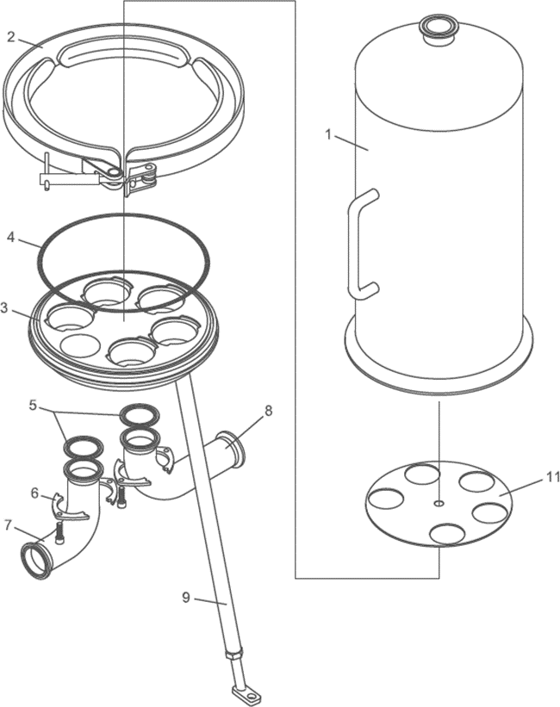

Fluid group 1 (dangerous) on request
article no., price u delivery time can be different.

DIMENSIONAL DATA
CARTRIDGE x HEIGHT (N) | R mm | S mm | N mm | C mm | E mm | VOLUME liters (V) | PED Category
08 x 10“ | 448 | 388 | 259 | 846 | 290 | 21.3 | II
08 x 20“ | 448 | 388 | 259 | 1096 | 540 | 35.5 | II
08 x 30“ | 448 | 388 | 259 | 1346 | 790 | 48.7 | II
08 x 40“ | 448 | 388 | 259 | 1596 | 1040 | 63.9 | II

CLAMP
 | WITHOUT DRAIN |  |  | WITH DRAIN
Dimension [mm] | A | L | Q | A | L | Q
2.0“ (50.8mm x 1.65mm) | 315 | 404 | 222 | 315 | 471 | 289

DIN 11851 MALE PART
 | WITHOUT DRAIN |  |  | WITH DRAIN
Dimension [mm] | A | L | Q | A | L | Q
DN50 | 315 | 449 | 244 | 315 | 516 | 311

BUTT WELD ASME BPE
 | WITHOUT DRAIN |  |  | WITH DRAIN
Dimension [mm] | A | B | Q | A | B | Q
2.0“ (50.8mm x 1.65mm) | 315 | 379 | 209 | 315 | 446 | 273

PACKAGING SIZE AND WEIGHT
CARTRIDGE x HEIGHT (N) | BOWL WEIGHT [kg] | TOTAL NET WEIGHT [kg] | PACKAGING SIZE [cm] | TOTAL WEIGHT PACKED [kg]
08 x 10“ | 7.0 | 27.0 | 75x40x42 | 30.0
08 x 20“ | 10.0 | 30.0 | 100x40x42 | 34.0
08 x 30“ | 13.0 | 3.0 | 125x40x42 | 38.0
08 x 40“ | 16.0 | 36.0 | 150x40x42 | 42.0

Please Note
In filter housings with a flange connection at the in- and outlet e.g. DIN-EN1092-1, ANSI, etc. the bends will be welded directly to the baseplate, instead of the standard flange connection described in the detailed drawing.

ORDER CODE AND TECHNICAL EQUIPMENT
Order-no. | No. of Cartridges | Bowl Height | Connection | Nominal Diameter | Gasket | With Vent TC 1.5“ | With Drain TC 1.5“
 | 08 | 20“ | DIN 11851 Male Part | DN 50 | Silicone | x | x
 | 08 | 20“ | DIN 11851 Male Part | DN 50 | EPDM | x | x
 | 08 | 20“ | DIN 11851 Male Part | DN 50 | Silicone | x | -
 | 08 | 20“ | DIN 11851 Male Part | DN 50 | EPDM | x | -
 | 08 | 20“ | TC | 2“ | Silicone | x | x
 | 08 | 20“ | TC | 2“ | EPDM | x | x
 | 08 | 20“ | TC | 2“ | Silicone | x | -
 | 08 | 20“ | TC | 2“ | EPDM | x | -
 | 08 | 20“ | Welding Stubs | 50.8 x 1.65 | Silicone | x | x
 | 08 | 20“ | Welding Stubs | 50.8 x 1.65 | EPDM | x | x
 | 08 | 20“ | Welding Stubs | 50.8 x 1.65 | Silicone | x | -
 | 08 | 20“ | Welding Stubs | 50.8 x 1.65 | EPDM | x | -
 | 08 | 30“ | DIN 11851 Male Part | DN 50 | Silicone | x | x
 | 08 | 30“ | DIN 11851 Male Part | DN 50 | EPDM | x | x
 | 08 | 30“ | DIN 11851 Male Part | DN 50 | Silicone | x | -
 | 08 | 30“ | DIN 11851 Male Part | DN 50 | EPDM | x | -
 | 08 | 30“ | TC | 2“ | Silicone | x | x
 | 08 | 30“ | TC | 2“ | EPDM | x | x
 | 08 | 30“ | TC | 2“ | Silicone | x | -
 | 08 | 30“ | TC | 2“ | EPDM | x | -
 | 08 | 30“ | Welding Stubs | 50.8 x 1.65 | Silicone | x | x
 | 08 | 30“ | Welding Stubs | 50.8 x 1.65 | EPDM | x | x
 | 08 | 30“ | Welding Stubs | 50.8 x 1.65 | Silicone | x | -
 | 08 | 30“ | Welding Stubs | 50.8 x 1.65 | EPDM | x | -
 | 08 | 40“ | DIN 11851 Male Part | DN 50 | Silicone | x | x
 | 08 | 40“ | DIN 11851 Male Part | DN 50 | EPDM | x | x
 | 08 | 40“ | DIN 11851 Male Part | DN 50 | Silicone | x | -
 | 08 | 40“ | DIN 11851 Male Part | DN 50 | EPDM | x | -
 | 08 | 40“ | TC | 2“ | Silicone | x | x
 | 08 | 40“ | TC | 2“ | EPDM | x | x
 | 08 | 40“ | TC | 2“ | Silicone | x | -
 | 08 | 40“ | TC | 2“ | EPDM | x | -
 | 08 | 40“ | Welding Stubs | 50.8 x 1.65 | Silicone | x | x
 | 08 | 40“ | Welding Stubs | 50.8 x 1.65 | EPDM | x | x
 | 08 | 40“ | Welding Stubs | 50.8 x 1.65 | Silicone | x | -
 | 08 | 40“ | Welding Stubs | 50.8 x 1.65 | EPDM | x | -

XX = 25 (Adapter 25 / code 7) 20
XX = 28 (Sartorius Adapter 28 tripple Bayonet)

SPARE PARTS
POS. | DESCRIPTION | MATERIAL | PART NO. | Q.TY
1 | HOUSING BOWL | AISI 316L |  | 1
2 | V-BAND | AISI 304 |  | 1
3 | CARTRIDGE PLATE | AISI 316L |  | 1
4 | O-RING d=5.35 ID=266.06 | SILICONE |  | 1
5 | GASKET CLAMP | PTFE |  | 2
6 | BEND FLANGE | AISI 304 |  | 4
7 | INLET BEND | AISI 316L |  | 1
8 | OUTLET BEND | AISI 316L |  | 1
9 | COMPLETE LEG | AISI 304 |  | 3
11 | PROTECTION PLATE | AISI 316L |  | 1
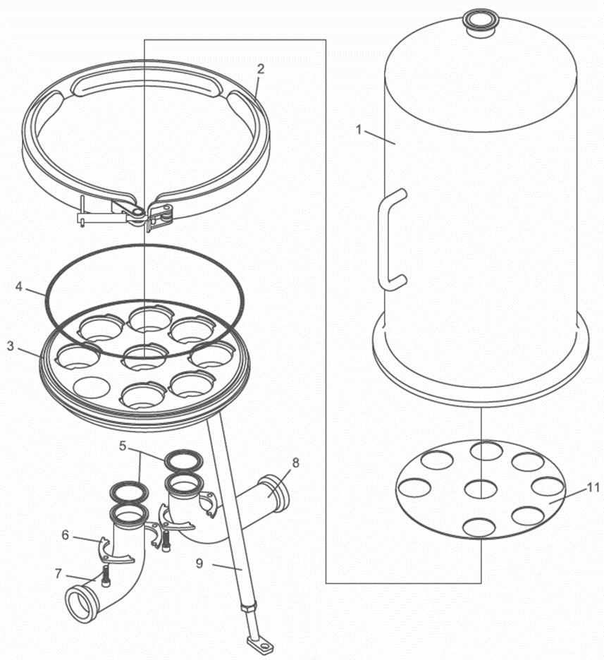

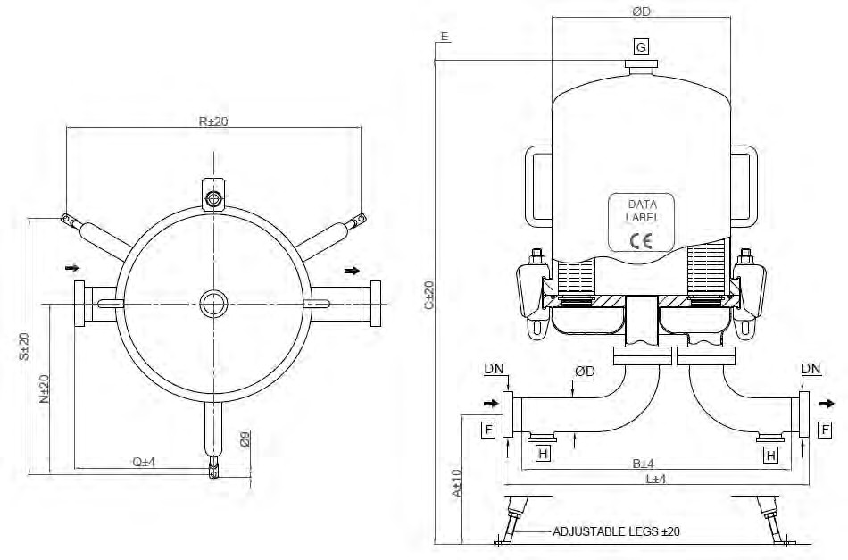

Fluid group 1 (dangerous) on request
article no., price u delivery time can be different.

DIMENSIONAL DATA
CARTRIDGE x HEIGHT (N) | R mm | S mm | N mm | C mm | E mm | VOLUME liters (V) | PED Category
12 x 10“ | 425 | 410 | 279 | 930 | 290 | 41 | II
12 x 20“ | 425 | 410 | 279 | 1180 | 540 | 66 | II
12 x 30“ | 425 | 410 | 279 | 1430 | 790 | 88 | II
12 x 40“ | 425 | 410 | 279 | 1680 | 1040 | 112 | III

CLAMP
 | WITHOUT DRAIN |  |  | WITH DRAIN
Dimension [mm] | A | L | Q | A | L | Q
2.5“ (63.5mm x 1.65mm) | 326 | 493 | 225 | 326 | 573 | 225

DIN 11851 MALE PART
 | WITHOUT DRAIN |  |  | WITH DRAIN
Dimension [mm] | A | L | Q | A | L | Q
DN65 | 326 | 547 | 252 | 326 | 627 | 252

BUTT WELD ASME BPE
 | WITHOUT DRAIN |  |  | WITH DRAIN
Dimension [mm] | A | B | Q | A | B | Q
2.5“ (63.5mm x 1.65mm) | 326 | 467 | 212 | 326 | 547 | 212

PACKAGING SIZE AND WEIGHT
CARTRIDGE x HEIGHT (N) | BOWL WEIGHT [kg] | TOTAL NET WEIGHT [kg] | PACKAGING SIZE [cm] | TOTAL WEIGHT PACKED [kg]
12 x 10“ | 10.0 | 58.0 | 75x53x54 | 63.0
12 x 20“ | 14.5 | 62.0 | 100x53x54 | 67.0
12 x 30“ | 19.0 | 66.0 | 125x53x54 | 71.0
12 x 40“ | 23.5 | 70.0 | 150x53x54 | 76.0

ORDER CODE AND TECHNICAL EQUIPMENT
Order-no. | No. of Cartridges | Bowl Height | Connection | Nominal Diameter | Gasket | With Vent TC 1.5“ | With Drain TC 1.5“
 | 12 | 30“ | DIN 11851 Male Part | DN 65 | Silicone | x | x
 | 12 | 30“ | DIN 11851 Male Part | DN 65 | EPDM | x | x
 | 12 | 30“ | DIN 11851 Male Part | DN 65 | Silicone | x | -
 | 12 | 30“ | DIN 11851 Male Part | DN 65 | EPDM | x | -
 | 12 | 30“ | TC | 2.5“ | Silicone | x | x
 | 12 | 30“ | TC | 2.5“ | EPDM | x | x
 | 12 | 30“ | TC | 2.5“ | Silicone | x | -
 | 12 | 30“ | TC | 2.5“ | EPDM | x | -
 | 12 | 30“ | Welding Stubs | 63.5 x 1.65 | Silicone | x | x
 | 12 | 30“ | Welding Stubs | 63.5 x 1.65 | EPDM | x | x
 | 12 | 30“ | Welding Stubs | 63.5 x 1.65 | Silicone | x | -
 | 12 | 30“ | Welding Stubs | 63.5 x 1.65 | EPDM | x | -
 | 12 | 40“ | DIN 11851 Male Part | DN 65 | Silicone | x | x
 | 12 | 40“ | DIN 11851 Male Part | DN 65 | EPDM | x | x
 | 12 | 40“ | DIN 11851 Male Part | DN 65 | Silicone | x | -
 | 12 | 40“ | DIN 11851 Male Part | DN 65 | EPDM | x | -
 | 12 | 40“ | TC | 2.5“ | Silicone | x | x
 | 12 | 40“ | TC | 2.5“ | EPDM | x | x
 | 12 | 40“ | TC | 2.5“ | Silicone | x | -
 | 12 | 40“ | TC | 2.5“ | EPDM | x | -
 | 12 | 40“ | Welding Stubs | 63.5 x 1.65 | Silicone | x | x
 | 12 | 40“ | Welding Stubs | 63.5 x 1.65 | EPDM | x | x
 | 12 | 40“ | Welding Stubs | 63.5 x 1.65 | Silicone | x | -
 | 12 | 40“ | Welding Stubs | 63.5 x 1.65 | EPDM | x | -

XX = 25 (Adapter 25 / code 7) 24
XX = 28 (Sartorius Adapter 28 tripple Bayonet)

SPARE PARTS
POS. | DESCRIPTION | MATERIAL | PART NO. | Q.TY
1 | HOUSING BOWL | AISI 316L |  | 1
2 | BOLT CLAMP M16 | AISI 316Ti
3 | O-RING d=7.00 ID=342.30 | SILICONE |  | 1
4 | CARTRIDGE PLATE | AISI 316L |  | 1
5 | LEG | AISI 304 |  | 3
6 | FOOT | AISI 304 |  | 3
7 | CLAMP 3“ | AISI 304 |  | 2
8.1 | GASKET CLAMP 3“ | PTFE |  | 2
8.2 | O-RING d=5.34 ID=100.00 | SILICONE |  | 2
9 | INLET BEND | AISI 316L |  | 1
10 | OUTLET BEND | AISI 316L |  | 1
11 | PROTECTION PLATE | AISI 316L |  | 1
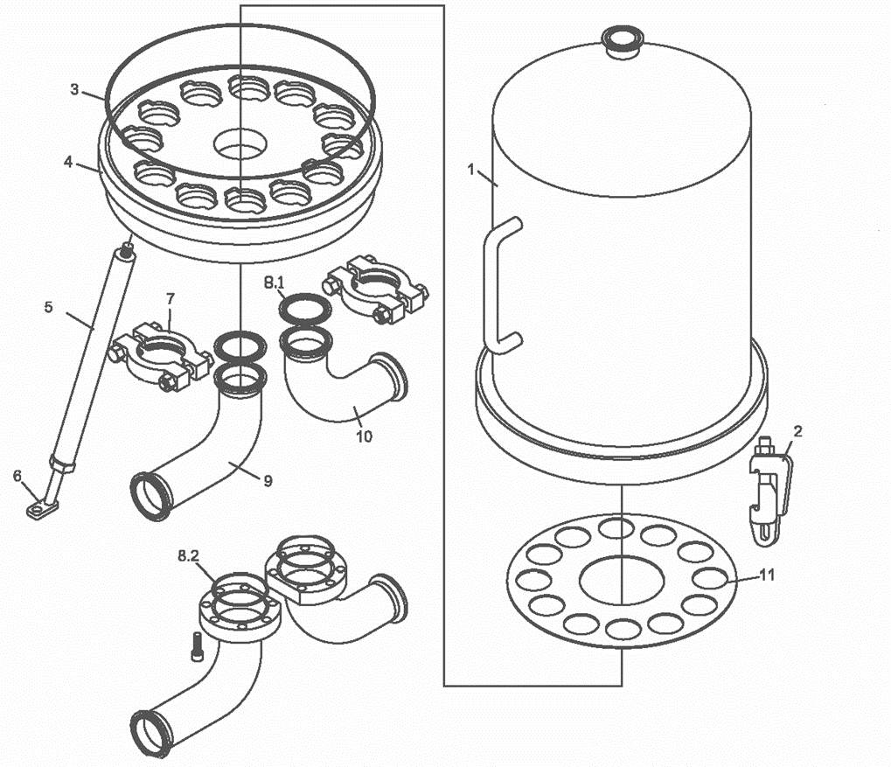

Fluid group 1 (dangerous) on request
article no., price u delivery time can be different.

DIMENSIONAL DATA
CARTRIDGE x HEIGHT (N) | R mm | S mm | N mm | C mm | E mm | VOLUME liters (V) | PED Category
18 x 10“ | 505 | 480 | 304 | 950 | 290 | 54 | II
18 x 20“ | 505 | 480 | 304 | 1200 | 540 | 85 | II
18 x 30“ | 505 | 480 | 304 | 1450 | 790 | 115 | III
18 x 40“ | 505 | 480 | 304 | 1700 | 1040 | 146 | III

CLAMP
 | WITHOUT DRAIN |  |  | WITH DRAIN
Dimension [mm] | A | L | Q | A | L | Q
2.5“ (63.5mm x 1.65mm) [Standard] | 325 | 509 | 225 | 325 | 589 | 225
3.0“ (76.2mm x 1.65mm) | 297 | 565 | 253 | 297 | 645 | 253

DIN 11851 MALE PART
 | WITHOUT DRAIN |  |  | WITH DRAIN
Dimension [mm] | A | L | Q | A | L | Q
DN65 [Standard] | 325 | 564 | 252 | 325 | 644 | 252
DN80 | 316 | 620 | 276 | 316 | 700 | 276

BUTT WELD ASME BPE
 | WITHOUT DRAIN |  |  | WITH DRAIN
Dimension [mm] | A | B | Q | A | B | Q
2.5“ (63.5mm x 1.65mm) [Standard] | 325 | 482 | 212 | 325 | 565 | 212
3.0“ (76.2mm x 1.65mm) | 297 | 540 | 240 | 297 | 620 | 240

PACKAGING SIZE AND WEIGHT
CARTRIDGE x HEIGHT (N) | BOWL WEIGHT [kg] | TOTAL NET WEIGHT [kg] | PACKAGING SIZE [cm] | TOTAL WEIGHT PACKED [kg]
18 x 10“ | 12.0 | 59.0 | 78x58x59 | 64.0
18 x 20“ | 17.0 | 63.0 | 103x58x59 | 68.0
18 x 30“ | 22.0 | 68.0 | 128x58x59 | 74.0
18 x 40“ | 27.0 | 74.0 | 153x58x59 | 80.0

ORDER CODE AND TECHNICAL EQUIPMENT
Order-no. | No. of Cartridges | Bowl Height | Connection | Nominal Diameter | Gasket | With Vent TC 1.5“ | With Drain TC 1.5“ | Standard Dimension
 | 18 | 30“ | DIN 11851 Male Part | DN 65 | Silicone | x | x | x
 | 18 | 30“ | DIN 11851 Male Part | DN 80 | Silicone | x | x
 | 18 | 30“ | DIN 11851 Male Part | DN 65 | EPDM | x | x | x
 | 18 | 30“ | DIN 11851 Male Part | DN 80 | EPDM | x | x
 | 18 | 30“ | DIN 11851 Male Part | DN 65 | Silicone | x | - | x
 | 18 | 30“ | DIN 11851 Male Part | DN 80 | Silicone | x | -
 | 18 | 30“ | DIN 11851 Male Part | DN 65 | EPDM | x | - | x
 | 18 | 30“ | DIN 11851 Male Part | DN 80 | EPDM | x | -
 | 18 | 30“ | TC | 2.5“ | Silicone | x | x | x
 | 18 | 30“ | TC | 3.0“ | Silicone | x | x
 | 18 | 30“ | TC | 2.5“ | EPDM | x | x | x
 | 18 | 30“ | TC | 3.0“ | EPDM | x | x
 | 18 | 30“ | TC | 2.5“ | Silicone | x | - | x
 | 18 | 30“ | TC | 3.0“ | Silicone | x | -
 | 18 | 30“ | TC | 2.5“ | EPDM | x | - | x
 | 18 | 30“ | TC | 3.0“ | EPDM | x | -
 | 18 | 30“ | Welding Stubs | 63.5 x 1.65 | Silicone | x | x | x
 | 18 | 30“ | Welding Stubs | 76.2 x 1.65 | Silicone | x | x
 | 18 | 30“ | Welding Stubs | 63.5 x 1.65 | EPDM | x | x | x
 | 18 | 30“ | Welding Stubs | 76.2 x 1.65 | EPDM | x | x
 | 18 | 30“ | Welding Stubs | 63.5 x 1.65 | Silicone | x | - | x
 | 18 | 30“ | Welding Stubs | 76.2 x 1.65 | Silicone | x | -
 | 18 | 30“ | Welding Stubs | 63.5 x 1.65 | EPDM | x | - | x
 | 18 | 30“ | Welding Stubs | 76.2 x 1.65 | EPDM | x | -
 | 18 | 40“ | DIN 11851 Male Part | DN 65 | Silicone | x | x | x
 | 18 | 40“ | DIN 11851 Male Part | DN 80 | Silicone | x | x
 | 18 | 40“ | DIN 11851 Male Part | DN 65 | EPDM | x | x | x
 | 18 | 40“ | DIN 11851 Male Part | DN 80 | EPDM | x | x
 | 18 | 40“ | DIN 11851 Male Part | DN 65 | Silicone | x | - | x
 | 18 | 40“ | DIN 11851 Male Part | DN 80 | Silicone | x | -
 | 18 | 40“ | DIN 11851 Male Part | DN 65 | EPDM | x | - | x
 | 18 | 40“ | DIN 11851 Male Part | DN 80 | EPDM | x | -
 | 18 | 40“ | TC | 2.5“ | Silicone | x | x | x
 | 18 | 40“ | TC | 3.0“ | Silicone | x | x
 | 18 | 40“ | TC | 2.5“ | EPDM | x | x | x
 | 18 | 40“ | TC | 3.0“ | EPDM | x | x
 | 18 | 40“ | TC | 2.5“ | Silicone | x | - | x
 | 18 | 40“ | TC | 3.0“ | Silicone | x | -
 | 18 | 40“ | TC | 2.5“ | EPDM | x | - | x
 | 18 | 40“ | TC | 3.0“ | EPDM | x | -
 | 18 | 40“ | Welding Stubs | 63.5 x 1.65 | Silicone | x | x | x
 | 18 | 40“ | Welding Stubs | 76.2 x 1.65 | Silicone | x | x
 | 18 | 40“ | Welding Stubs | 63.5 x 1.65 | EPDM | x | x | x
 | 18 | 40“ | Welding Stubs | 76.2 x 1.65 | EPDM | x | x
 | 18 | 40“ | Welding Stubs | 63.5 x 1.65 | Silicone | x | - | x
 | 18 | 40“ | Welding Stubs | 76.2 x 1.65 | Silicone | x | -
 | 18 | 40“ | Welding Stubs | 63.5 x 1.65 | EPDM | x | - | x
 | 18 | 40“ | Welding Stubs | 76.2 x 1.65 | EPDM | x | -
XX = 25 (Adapter 25 / code 7) 28
XX = 28 (Sartorius Adapter 28 tripple Bayonet)

SPARE PARTS
POS. | DESCRIPTION | MATERIAL | PART NO. | Q.TY
1 | HOUSING BOWL | AISI 316L |  | 1
2 | BOLT CLAMP M16 | AISI 316Ti
3 | O-RING d=7.00 ID=393.10 | SILICONE |  | 1
4 | CARTRIDGE PLATE | AISI 316L |  | 1
5 | LEG | AISI 304 |  | 3
6 | FOOT | AISI 304 |  | 3
7 | CLAMP 3“ | AISI 304 |  | 2
8.1 | GASKET CLAMP 3“ | PTFE |  | 2
8.2 | O-RING d=5.34 ID=110.50 | SILICONE |  | 2
9 | INLET BEND | AISI 316L |  | 1
10 | OUTLET BEND | AISI 316L |  | 1
11 | PROTECTION PLATE | AISI 316L |  | 1

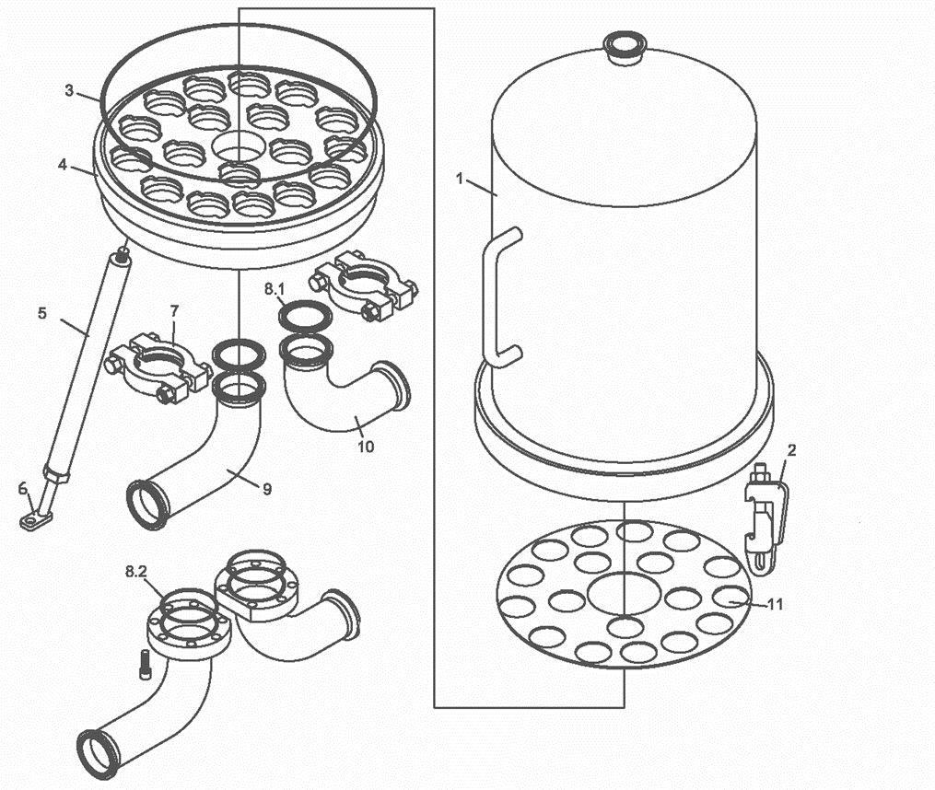

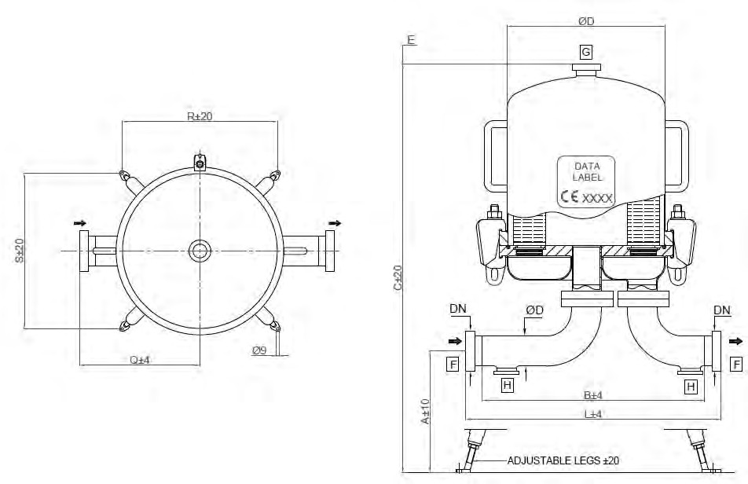

Fluid group 1 (dangerous) on request
article no., price u delivery time can be different.

DIMENSIONAL DATA
CARTRIDGE x HEIGHT (N) | R mm | S mm | N mm | C mm | E mm | VOLUME liters (V) | PED Category
24 x 10“ | 465 | 455 | - | 970 | 290 | 73 | II
24 x 20“ | 465 | 455 | - | 1220 | 540 | 112 | II
24 x 30“ | 465 | 455 | - | 1470 | 790 | 151 | III
24 x 40“ | 465 | 455 | - | 1720 | 1040 | 190 | III

CLAMP
 | WITHOUT DRAIN |  |  | WITH DRAIN
Dimension [mm] | A | L | Q | A | L | Q
2.5“ (63.5mm x 1.65mm) [Standard] | 318 | 509 | 563 | 318 | 643 | 264
3.0“ (76.2mm x 1.65mm) | 292 | 578 | 252 | 292 | 660 | 252
4.0“ ( 101.6mm x 2.11mm) | 300 | 566 | 245 | 300 | 647 | 245

DIN 11851 MALE PART
 | WITHOUT DRAIN |  |  | WITH DRAIN
Dimension [mm] | A | L | Q | A | L | Q
DN65 [Standard] | 318 | 618 | 291 | 318 | 698 | 291
DN80 | 331 | 616 | 295 | 331 | 696 | 295
DN100 | 300 | 638 | 281 | 300 | 718 | 281

BUTT WELD ASME BPE
 | WITHOUT DRAIN |  |  | WITH DRAIN
Dimension [mm] | A | B | Q | A | B | Q
2.5“ (63.5mm x 1.65mm) [Standard] | 318 | 539 | 252 | 318 | 518 | 252
3.0“ (76.2mm x 1.65mm) | 292 | 554 | 239 | 292 | 547 | 239
DN4“ (101.6mm x 2.11mm) | 300 | 534 | 229 | 300 | 603 | 229

PACKAGING SIZE AND WEIGHT
CARTRIDGE x HEIGHT (N) | BOWL WEIGHT [kg] | TOTAL NET WEIGHT [kg] | PACKAGING SIZE [cm] | TOTAL WEIGHT PACKED [kg]
24 x 10“ | 18.0 | 88.0 | 80x63x64 | 95.0
24 x 20“ | 27.0 | 97.0 | 105x63x64 | 105.0
24 x 30“ | 35.0 | 105.0 | 130x63x64 | 113.0
24 x 40“ | 44.0 | 114.0 | 155x63x64 | 122.0

ORDER CODE AND TECHNICAL EQUIPMENT
Order-no. | No. of Cartridges | Bowl Height | Connection | Nominal Diameter | Gasket | With Vent TC 1.5“ | With Drain TC 1.5“ | Standard Dimension
 | 24 | 30" | DIN 11851 Male Part | DN 65 | Silicone | x | x | x
 | 24 | 30" | DIN 11851 Male Part | DN 80 | Silicone | x | x
 | 24 | 30" | DIN 11851 Male Part | DN 100 | Silicone | x | x
 | 24 | 30" | DIN 11851 Male Part | DN 65 | EPDM | x | x | x
 | 24 | 30" | DIN 11851 Male Part | DN 80 | EPDM | x | x
 | 24 | 30" | DIN 11851 Male Part | DN 100 | EPDM | x | x
 | 24 | 30" | DIN 11851 Male Part | DN 65 | Silicone | x | - | x
 | 24 | 30" | DIN 11851 Male Part | DN 80 | Silicone | x | -
 | 24 | 30" | DIN 11851 Male Part | DN 100 | Silicone | x | -
 | 24 | 30" | DIN 11851 Male Part | DN 65 | EPDM | x | - | x
 | 24 | 30" | DIN 11851 Male Part | DN 80 | EPDM | x | -
 | 24 | 30" | DIN 11851 Male Part | DN 100 | EPDM | x | -
 | 24 | 30" | TC | 2,5" | Silicone | x | x | x
 | 24 | 30" | TC | 3" | Silicone | x | x
 | 24 | 30" | TC | 4" | Silicone | x | x
 | 24 | 30" | TC | 2,5" | EPDM | x | x | x
 | 24 | 30" | TC | 3" | EPDM | x | x
 | 24 | 30" | TC | 4" | EPDM | x | x
 | 24 | 30" | TC | 2,5" | Silicone | x | - | x
 | 24 | 30" | TC | 3" | Silicone | x | -
 | 24 | 30" | TC | 4" | Silicone | x | -
 | 24 | 30" | TC | 2,5" | EPDM | x | - | x
 | 24 | 30" | TC | 3" | EPDM | x | -
 | 24 | 30" | TC | 4" | EPDM | x | -
 | 24 | 30" | Welding Stubs | 63,5 x 1.65 | Silicone | x | x | x
 | 24 | 30" | Welding Stubs | 76.2 x 1.65 | Silicone | x | x
 | 24 | 30" | Welding Stubs | 101.6 x 2.11 | Silicone | x | x
 | 24 | 30" | Welding Stubs | 63,5 x 1.65 | EPDM | x | x | x
 | 24 | 30" | Welding Stubs | 76.2 x 1.65 | EPDM | x | x
 | 24 | 30" | Welding Stubs | 101.6 x 2.11 | EPDM | x | x
 | 24 | 30" | Welding Stubs | 63,5 x 1.65 | Silicone | x | - | x
 | 24 | 30" | Welding Stubs | 76.2 x 1.65 | Silicone | x | -
 | 24 | 30" | Welding Stubs | 101.6 x 2.11 | Silicone | x | -
 | 24 | 30" | Welding Stubs | 63,5 x 1.65 | EPDM | x | - | x
 | 24 | 30" | Welding Stubs | 76.2 x 1.65 | EPDM | x | -
 | 24 | 30" | Welding Stubs | 101.6 x 2.11 | EPDM | x | -

ORDER CODE AND TECHNICAL EQUIPMENT
Order-no. | No. of Cartridges | Bowl Height | Connection | Nominal Diameter | Gasket | With Vent TC 1.5“ | With Drain TC 1.5“ | Standard Dimension
 | 24 | 40" | DIN 11851 Male Part | DN 65 | Silicone | x | x | x
 | 24 | 40" | DIN 11851 Male Part | DN 80 | Silicone | x | x
 | 24 | 40" | DIN 11851 Male Part | DN 100 | Silicone | x | x
 | 24 | 40" | DIN 11851 Male Part | DN 65 | EPDM | x | x | x
 | 24 | 40" | DIN 11851 Male Part | DN 80 | EPDM | x | x
 | 24 | 40" | DIN 11851 Male Part | DN 100 | EPDM | x | x
 | 24 | 40" | DIN 11851 Male Part | DN 65 | Silicone | x | - | x
 | 24 | 40" | DIN 11851 Male Part | DN 80 | Silicone | x | -
 | 24 | 40" | DIN 11851 Male Part | DN 100 | Silicone | x | -
 | 24 | 40" | DIN 11851 Male Part | DN 65 | EPDM | x | - | x
 | 24 | 40" | DIN 11851 Male Part | DN 80 | EPDM | x | -
 | 24 | 40" | DIN 11851 Male Part | DN 100 | EPDM | x | -
 | 24 | 40" | TC | 2,5" | Silicone | x | x | x
 | 24 | 40" | TC | 3" | Silicone | x | x
 | 24 | 40" | TC | 4" | Silicone | x | x
 | 24 | 40" | TC | 2,5" | EPDM | x | x | x
 | 24 | 40" | TC | 3" | EPDM | x | x
 | 24 | 40" | TC | 4" | EPDM | x | x
 | 24 | 40" | TC | 2,5" | Silicone | x | - | x
 | 24 | 40" | TC | 3" | Silicone | x | -
 | 24 | 40" | TC | 4" | Silicone | x | -
 | 24 | 40" | TC | 2,5" | EPDM | x | - | x
 | 24 | 40" | TC | 3" | EPDM | x | -
 | 24 | 40" | TC | 4" | EPDM | x | -
 | 24 | 40" | Welding Stubs | 63,5 x 1.65 | Silicone | x | x | x
 | 24 | 40" | Welding Stubs | 76.2 x 1.65 | Silicone | x | x
 | 24 | 40" | Welding Stubs | 101.6 x 2.11 | Silicone | x | x
 | 24 | 40" | Welding Stubs | 63,5 x 1.65 | EPDM | x | x | x
 | 24 | 40" | Welding Stubs | 76.2 x 1.65 | EPDM | x | x
 | 24 | 40" | Welding Stubs | 101.6 x 2.11 | EPDM | x | x
 | 24 | 40" | Welding Stubs | 63,5 x 1.65 | Silicone | x | - | x
 | 24 | 40" | Welding Stubs | 76.2 x 1.65 | Silicone | x | -
 | 24 | 40" | Welding Stubs | 101.6 x 2.11 | Silicone | x | -
 | 24 | 40" | Welding Stubs | 63,5 x 1.65 | EPDM | x | - | x
 | 24 | 40" | Welding Stubs | 76.2 x 1.65 | EPDM | x | -
 | 24 | 40" | Welding Stubs | 101.6 x 2.11 | EPDM | x | -

SPARE PARTS
POS. | DESCRIPTION | MATERIAL | PART NO. | Q.TY
1 | HOUSING BOWL | AISI 316L |  | 1
2 | BOLT CLAMP M16 | AISI 316Ti
3 | O-RING d=7.00 ID=443.40 | SILICONE |  | 1
4 | CARTRIDGE PLATE | AISI 316L |  | 1
5 | LEG | AISI 304 |  | 4
6 | FOOT | AISI 304 |  | 4
7 | CLAMP 4“ | AISI 304 |  | 2
8.1 | GASKET CLAMP 4“ | PTFE |  | 2
8.2 | O-RING d=5.34 ID=136.50 | SILICONE |  | 2
9 | INLET BEND | AISI 316L |  | 1
10 | OUTLET BEND | AISI 316L |  | 1
11 | PROTECTION PLATE | AISI 316L |  | 1
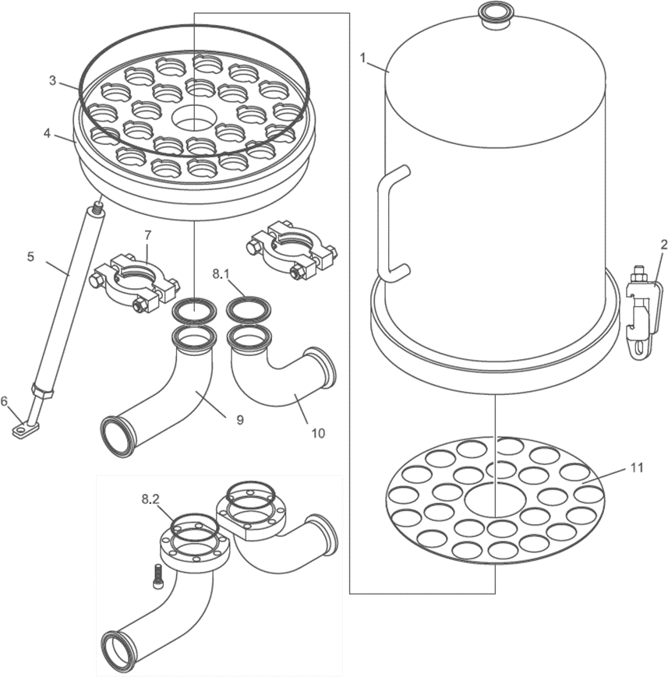

Fluid group 1 (dangerous) on request
article no., price u delivery time can be different.

DIMENSIONAL DATA
CARTRIDGE x HEIGHT (N) | R mm | S mm | N mm | C mm | E mm | VOLUME liters (V) | PED Category
30 x 10“ | 550 | 550 | - | 1000 | 290 | 118 | III
30 x 20“ | 550 | 550 | - | 1250 | 540 | 176 | III
30 x 30“ | 550 | 550 | - | 1500 | 790 | 235 | III
30 x 40“ | 550 | 550 | - | 1750 | 1040 | 293 | III

CLAMP
 | WITHOUT DRAIN |  |  | WITH DRAIN
Dimension [mm] | A | L | Q | A | L | Q
3.0“ (76.2mm x 1.65mm) [Standard] | 292 | 685 | 323 | 292 | 765 | 323
4.0“ ( 101.6mm x 2.11mm) | 300 | 662 | 306 | 30 | 742 | 306

DIN 11851 MALE PART
 | WITHOUT DRAIN |  |  | WITH DRAIN
Dimension [mm] | A | L | Q | A | L | Q
DN80 [Standard] | 331 | 712 | 356 | 331 | 792 | 356
DN100 | 300 | 734 | 342 | 300 | 814 | 342

BUTT WELD ASME BPE
 | WITHOUT DRAIN |  |  | WITH DRAIN
Dimension [mm] | A | B | Q | A | B | Q
3.0“ (76.2mm x 1.65mm) [Standard] | 292 | 660 | 310 | 292 | 740 | 310
DN 4.0“ (101.6mm x 2.11mm) | 300 | 630 | 290 | 300 | 710 | 290

PACKAGING SIZE AND WEIGHT
CARTRIDGE x HEIGHT (N) | BOWL WEIGHT [kg] | TOTAL NET WEIGHT [kg] | PACKAGING SIZE [cm] | TOTAL WEIGHT PACKED [kg]
30 x 10“ | 28.0 | 93.0 | 80x100x78 | 112.0
30 x 20“ | 38.0 | 101.0 | 105x100x78 | 121.0
30 x 30“ | 48.0 | 109.0 | 130x100x78 | 131.0
30 x 40“ | 58.0 | 117.0 | 155x100x78 | 140.0

ORDER CODE AND TECHNICAL EQUIPMENT
Order-no. | No. of Cartridges | Bowl Height | Connection | Nominal Diameter | Gasket | With Vent TC 1.5“ | With Drain TC 1.5“ | Standard Dimension
 | 30 | 30“ | DIN 11851 Male Part | DN 80 | Silicone | x | x | x
 | 30 | 30“ | DIN 11851 Male Part | DN 100 | Silicone | x | x
 | 30 | 30“ | DIN 11851 Male Part | DN 80 | EPDM | x | x | x
 | 30 | 30“ | DIN 11851 Male Part | DN 100 | EPDM | x | x
 | 30 | 30“ | DIN 11851 Male Part | DN 80 | Silicone | x | - | x
 | 30 | 30“ | DIN 11851 Male Part | DN 100 | Silicone | x | -
 | 30 | 30“ | DIN 11851 Male Part | DN 80 | EPDM | x | - | x
 | 30 | 30“ | DIN 11851 Male Part | DN 100 | EPDM | x | -
 | 30 | 30“ | TC | 3.0“ | Silicone | x | x | x
 | 30 | 30“ | TC | 4.0“ | Silicone | x | x
 | 30 | 30“ | TC | 3.0“ | EPDM | x | x | x
 | 30 | 30“ | TC | 4.0“ | EPDM | x | x
 | 30 | 30“ | TC | 3.0“ | Silicone | x | - | x
 | 30 | 30“ | TC | 4.0“ | Silicone | x | -
 | 30 | 30“ | TC | 3.0“ | EPDM | x | - | x
 | 30 | 30“ | TC | 4.0“ | EPDM | x | -
 | 30 | 30“ | Welding Stubs | 76.2 x 1.65 | Silicone | x | x | x
 | 30 | 30“ | Welding Stubs | 101.6 x 1.65 | Silicone | x | x
 | 30 | 30“ | Welding Stubs | 76.2 x 1.65 | EPDM | x | x | x
 | 30 | 30“ | Welding Stubs | 101.6 x 1.65 | EPDM | x | x
 | 30 | 30“ | Welding Stubs | 76.2 x 1.65 | Silicone | x | - | x
 | 30 | 30“ | Welding Stubs | 101.6 x 1.65 | Silicone | x | -
 | 30 | 30“ | Welding Stubs | 76.2 x 1.65 | EPDM | x | - | x
 | 30 | 30“ | Welding Stubs | 101.6 x 1.65 | EPDM | x | -
 | 30 | 40“ | DIN 11851 Male Part | DN 80 | Silicone | x | x | x
 | 30 | 40“ | DIN 11851 Male Part | DN 100 | Silicone | x | x
 | 30 | 40“ | DIN 11851 Male Part | DN 80 | EPDM | x | x | x
 | 30 | 40“ | DIN 11851 Male Part | DN 100 | EPDM | x | x
 | 30 | 40“ | DIN 11851 Male Part | DN 80 | Silicone | x | - | x
 | 30 | 40“ | DIN 11851 Male Part | DN 100 | Silicone | x | -
 | 30 | 40“ | DIN 11851 Male Part | DN 80 | EPDM | x | - | x
 | 30 | 40“ | DIN 11851 Male Part | DN 100 | EPDM | x | -
 | 30 | 40“ | TC | 3.0“ | Silicone | x | x | x
 | 30 | 40“ | TC | 4.0“ | Silicone | x | x
 | 30 | 40“ | TC | 3.0“ | EPDM | x | x | x
 | 30 | 40“ | TC | 4.0“ | EPDM | x | x
 | 30 | 40“ | TC | 3.0“ | Silicone | x | - | x
 | 30 | 40“ | TC | 4.0“ | Silicone | x | -
 | 30 | 40“ | TC | 3.0“ | EPDM | x | - | x
 | 30 | 40“ | TC | 4.0“ | EPDM | x | -
 | 30 | 40“ | Welding Stubs | 76.2 x 1.65 | Silicone | x | x | x
 | 30 | 40“ | Welding Stubs | 101.6 x 1.65 | Silicone | x | x
 | 30 | 40“ | Welding Stubs | 76.2 x 1.65 | EPDM | x | x | x
 | 30 | 40“ | Welding Stubs | 101.6 x 1.65 | EPDM | x | x
 | 30 | 40“ | Welding Stubs | 76.2 x 1.65 | Silicone | x | - | x
 | 30 | 40“ | Welding Stubs | 101.6 x 1.65 | Silicone | x | -
 | 30 | 40“ | Welding Stubs | 76.2 x 1.65 | EPDM | x | - | x
 | 30 | 40“ | Welding Stubs | 101.6 x 1.65 | EPDM | x | -
XX = 25 (Adapter 25 / code 7) 37
XX = 28 (Sartorius Adapter 28 tripple Bayonet)

SPARE PARTS
POS. | DESCRIPTION | MATERIAL | PART NO. | Q.TY
1 | HOUSING BOWL | AISI 316L |  | 1
2 | BOLT CLAMP M16 | AISI 316Ti
3 | O-RING d=7.00 ID=532.30 | SILICONE |  | 1
4 | CARTRIDGE PLATE | AISI 316L |  | 1
5 | LEG | AISI 304 |  | 4
6 | FOOT | AISI 304 |  | 4
7 | CLAMP 4“ | AISI 304 |  | 2
8.1 | GASKET CLAMP 4“ | PTFE |  | 2
8.2 | O-RING d=5.34 ID=164.46 | SILICONE |  | 2
9 | INLET BEND | AISI 316L |  | 1
10 | OUTLET BEND | AISI 316L |  | 1
11 | PROTECTION PLATE | AISI 316L | - | 1

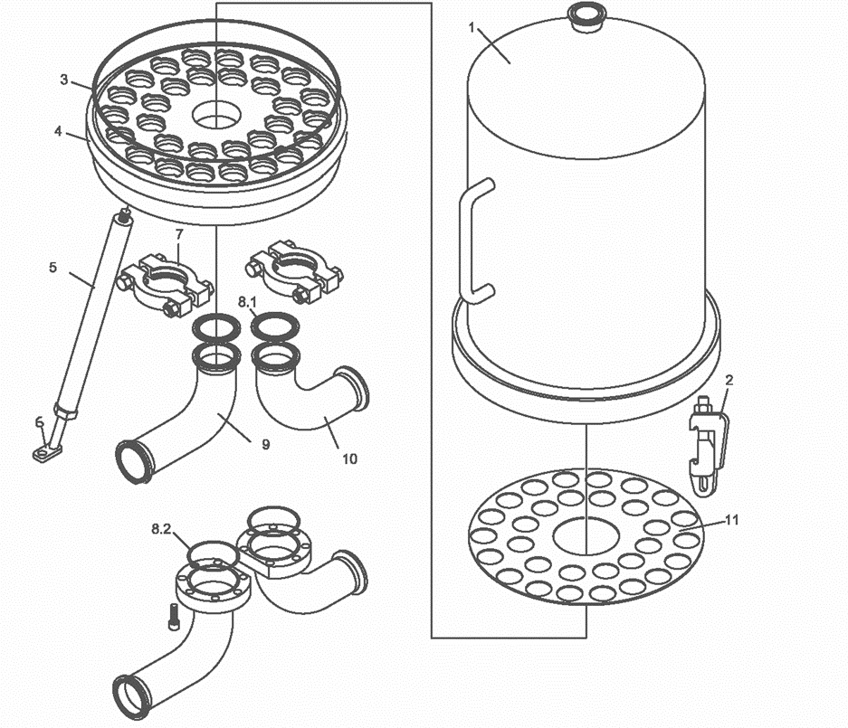

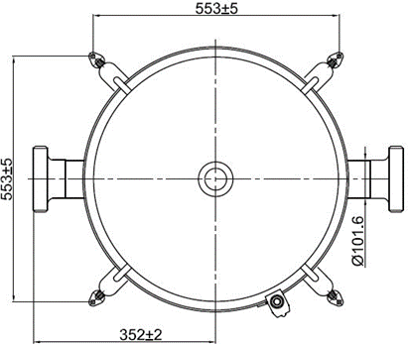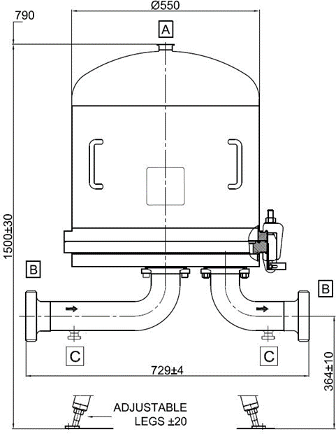
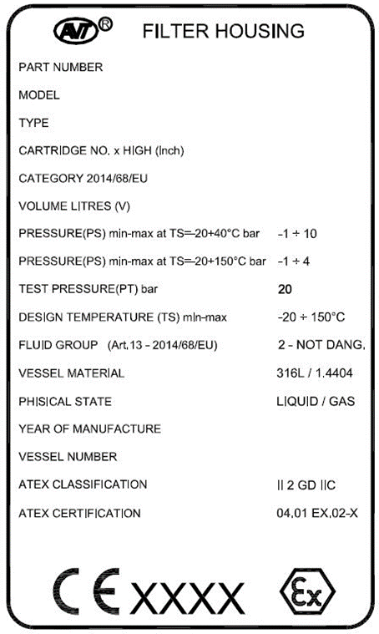
Fluid group 1 (dangerous) on request
article no., price u delivery time can be differ.
TECHNICHAL DATA
VESSEL RANGE | PRM
NO. CARTRIDGED x HEIGHT | 36 x 30“
CARTRIDGE SOCKET | 226 CODE 7
ATEX REGULATION | GROUP 2 - Cat 2 GASuDUST FLUID GR IIC zone 1u21
DESIGN CODE | DIN EN 13445
CERTIFICATION | PED 2014/68/EU
PED CATEGORY | III
DESIGN PRESSURE -20°C +40°C (PS) | -1bar...+10bar
DESIGN PRESSURE -20°C +150°C (PS) | -1bar...+4bar
DESIGN TEMP. MIN-MAX (TS) | -20°C...+150°C
VESSEL MATERIAL | 316L / 1.4404
TEST PRESSURE (PT) | 20 bar
TOTAL VESSEL VOLUME liters (V) | 235
FLUIDGROUP | 2
PHYSICAL STATE | LIQUID / GAS
SEALS MATERIAL | SILICONE
INTERNAL FINISH | MECHANICAL POLISHING
INTERNAL ROUGHNESS | RA <0.8 MICRON
EXTERNAL FINISH | MECHANICAL POLISHING
VENT CONNECTION A | CLAMP ASME 1.5“
IN/OUT CONNECTION B | DIN11851-DN100 MALE PART
DRAIN CONNECTION C | CLAMP ASME 1.5“

ORDER CODE AND TECHNICAL EQUIPMENT
Order-no. | No. of Cartridges | Bowl Height | Connection | Nominal Diameter | Gasket | With Vent TC 1.5“ | With Drain TC 1.5“ | Standard Diameter
 | 36 | 30“ | DIN 11851 Male Part | DN 100 | Silicone | x | - | x
 | 36 | 30“ | DIN 11851 Male Part | DN 100 | Silicone | x | x
 | 36 | 30“ | DIN 11851 Male Part | DN 100 | EPDM | x | - | x
 | 36 | 30“ | DIN 11851 Male Part | DN 100 | EPDM | x | x

XX = 25 (Adapter 25 / code 7) 40
XX = 28 (Sartorius Adapter 28 tripple Bayonet)

Type 810

Fluid group 1 (dangerous) Series SH

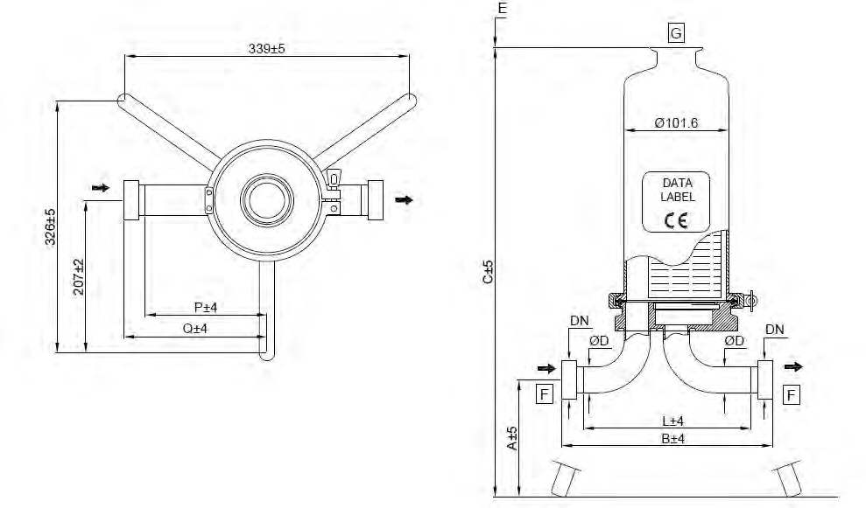
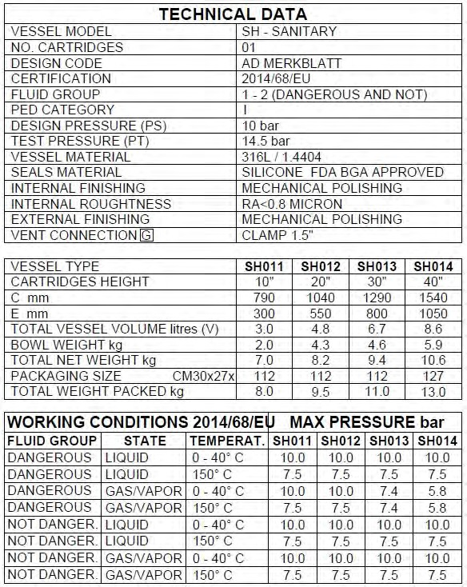
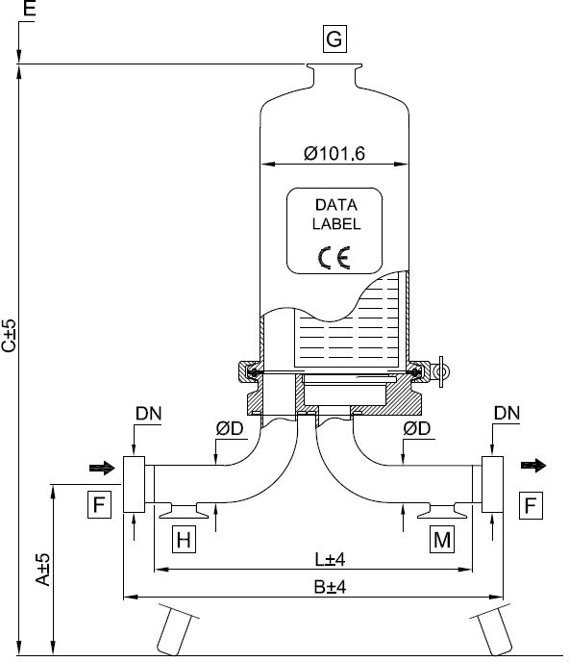

DIMENSIONAL DATA
CARTRIDGE x HEIGHT (N) | C mm | E mm | VOLUME liters (V) | PED Category | Fluid Group
01 x 10“ | 790 | 300 | 3.0 | I | 1 (dangerous)
01 x 20“ | 1040 | 550 | 4.8 | I | 1 (dangerous)
01 x 30“ | 1290 | 800 | 6.7 | II | 1 (dangerous)
01 x 40“ | 1540 | 1050 | 8.6 | II | 1 (dangerous)

CLAMP
 | WITHOUT DRAIN |  |  | WITH DRAIN
Dimension [mm] | A | B | Q | A | B | Q
1.0“ (25.4mm x 1.65mm) | 375 | 189 | 104 | 375 | 270 | 154
1.5“ (38,1mm x 1.65mm) | 355 | 220 | 122 | 355 | 370 | 198

DIN 11851 MALE PART
 | WITHOUT DRAIN |  |  | WITH DRAIN
Dimension [mm] | A | B | Q | A | B | Q
DN25 (25.4mm x 1.65mm) | 375 | 221 | 120 | 375 | 302 | 170
DN40 (38,1mm x 1.65mm) | 355 | 258 | 144 | 355 | 415 | 217
BUTT WELD ASME BPE
 | WITHOUT DRAIN |  |  | WITH DRAIN
Dimension [mm] | A | L | P | A | L | P
1.0“ (25.4mm x 1.65mm) | 375 | 163 | 91 | 375 | 244 | 141
1.5“ (38.1mm x 1.65mm) | 355 | 194 | 112 | 355 | 345 | 185

SMS MALE PART
 | WITHOUT DRAIN |  |  | WITH DRAIN
Dimension [mm] | A | B | Q | A | B | Q
1.0“ (25.4mm x 1.65mm) | 375 | 203 | 111 | 375 | 284 | 161
1.5“ (38,1mm x 1.65mm) | 355 | 240 | 133 | 355 | 391 | 208

ORDER CODE AND TECHNICAL EQUIPMENT
Order-no. | No. of Cartridges | Bowl Height | Connection | Nominal Diameter | Gasket | With Vent TC 1.5“ | With Drain TC 1.0“
 | 01 | 10“-40“ | DIN 11851 Male Part | DN 25 | Silicone | x | x
 | 01 | 10“-40“ | DIN 11851 Male Part | DN 25 | Silicone | x | -
 | 01 | 10“-40“ | DIN 11851 Male Part | DN 40 | Silicone | x | x
 | 01 | 10“-40“ | DIN 11851 Male Part | DN 40 | Silicone | x | -
 | 01 | 10“-40“ | TC | 1“ | Silicone | x | x
 | 01 | 10“-40“ | TC | 1.5“ | Silicone | x | -
 | 01 | 10“-40“ | TC | 1“ | Silicone | x | x
 | 01 | 10“-40“ | TC | 1.5“ | Silicone | x | -
 | 01 | 10“-40“ | Welding Stubs | 25.4 x 1.65 | Silicone | x | x
 | 01 | 10“-40“ | Welding Stubs | 381. x 1.65 | Silicone | x | -
 | 01 | 10“-40“ | Welding Stubs | 25.4 x 1.65 | Silicone | x | x
 | 01 | 10“-40“ | Welding Stubs | 38.1 x 1.65 | Silicone | x | -
 | 01 | 10“-40“ | SMS - Male part | 25.4 x 1.65 | Silicone | x | x
 | 01 | 10“-40“ | SMS - Male part | 381. x 1.65 | Silicone | x | -
 | 01 | 10“-40“ | SMS - Male part | 25.4 x 1.65 | Silicone | x | x
 | 01 | 10“-40“ | SMS - Male part | 38.1 x 1.65 | Silicone | x | -

„X“ = Placeholder for the bowl height:

1 = 10“
2 = 20“
3 = 30“
4 = 40“

SPARE PARTS
POS. | DESCRIPTION | MATERIAL | PART NO. | Q.TY
1 | HOUSING BOWL | AISI 316L |  | 1
2 | CLAMP 4“ | AISI 304 |  | 1
3 | CARFTRIDGES PLATE + BENDS | AISI 316L |  | 1
4  5 | GASKET CLAMP 4“ | SILICONE |  | 1
4  5 | LEG | AISI 304 |  | 3

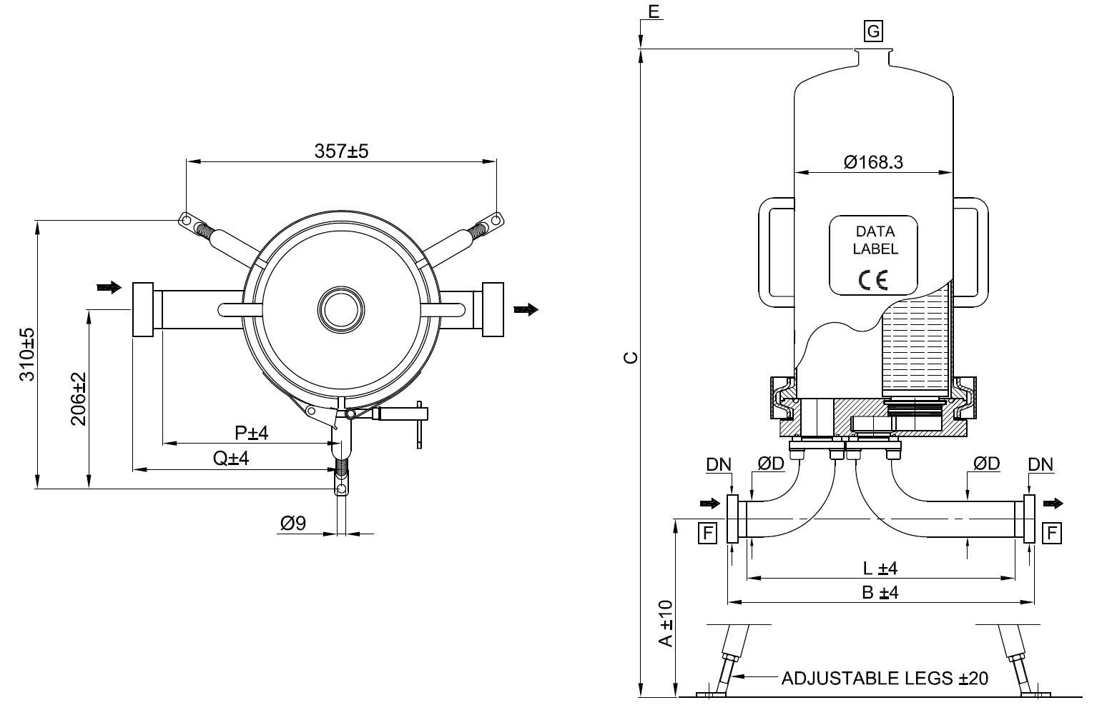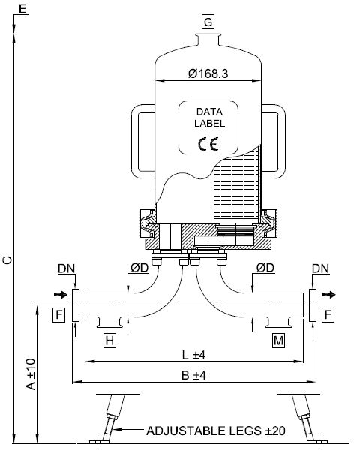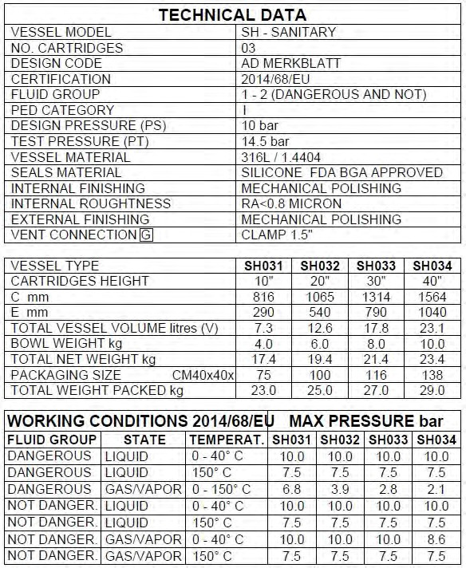

DIMENSIONAL DATA
CARTRIDGE x HEIGHT (N) | C mm | E mm | VOLUME liters (V) | PED Category | Fluid Group
03 x 10“ | 816 | 290 | 7.3 | II | 1 (dangerous)
03 x 20“ | 1065 | 540 | 12.6 | II | 1 (dangerous)
03 x 30“ | 1314 | 790 | 17.8 | II | 1 (dangerous)
03 x 40“ | 1564 | 1040 | 23.1 | III | 1 (dangerous)

CLAMP
 | WITHOUT DRAIN |  |  | WITH DRAIN
Dimension [mm] | A | B | Q | A | B | Q
1.5“ (38.1mm x 1.65mm) | 345 | 310 | 148 | 345 | 385 | 223

DIN 11851 MALE PART
 | WITHOUT DRAIN |  |  | WITH DRAIN
Dimension [mm] | A | B | Q | A | B | Q
DN40 (38.1mm x 1.65mm) | 345 | 351 | 168 | 345 | 426 | 243

BUTT WELD ASME BPE
 | WITHOUT DRAIN |  |  | WITH DRAIN
Dimension [mm] | A | L | P | A | L | P
1.5“ (38.1mm x 1.65mm) | 345 | 285 | 135 | 345 | 360 | 210

SMS MALE PART
 | WITHOUT DRAIN |  |  | WITH DRAIN
Dimension [mm] | A | B | Q | A | B | Q
1.5“ (38,1mm x 1.65mm) | 345 | 331 | 158 | 345 | 406 | 233

Please Note
In filter housings with a flange connection at the in- and outlet e.g. DIN-EN1092-1, ANSI, etc. the bends will be welded directly to the baseplate, instead of the standard flange connection described in the detailed drawing.

ORDER CODE AND TECHNICAL EQUIPMENT
Order-no. | No. of Cartridges | Bowl Height | Connection | Nominal Diameter | Gasket | With Vent TC 1.5“ | With Drain TC 1.5“
 | 03 | 10“-40“ | DIN 11851 Male Part | DN 40 | Silicone | x | x
 | 03 | 10“-40“ | DIN 11851 Male Part | DN 40 | Silicone | x | -
 | 03 | 10“-40“ | TC | 1.5“ | Silicone | x | x
 | 03 | 10“-40“ | TC | 1.5“ | Silicone | x | -
 | 03 | 10“-40“ | Welding Stubs | 38.1 x 1.65 | Silicone | x | x
 | 03 | 10“-40“ | Welding Stubs | 38.1 x 1.65 | Silicone | x | -
 | 03 | 10“-40“ | SMS - Male part | 38.1 x 1.65 | Silicone | x | x
 | 03 | 10“-40“ | SMS - Male part | 38.1 x 1.65 | Silicone | x | -

„X“ = Placeholder for the bowl height:

1 = 10“
2 = 20“
3 = 30“
4 = 40“

SPARE PARTS
POS. | DESCRIPTION | MATERIAL | PART NO. | Q.TY
1 | HOUSING BOWL | AISI 316L |  | 1
2 | V-BAND | AISI 304 |  | 1
3 | CARTRIDGE PLATE | AISI 316L |  | 1
4 | O-RING d=5.35 ID=158.11 | SILICONE |  | 1
5 | GASKET CLAMP 1.5“ | PTFE |  | 2
6 | BEND FLANGE | AISI 304 |  | 4
7 | INLET BEND | AISI 316L |  | 1
8 | OUTLET BEND | AISI 316L |  | 1
9 | COMPLETE LEG | AISI 304 |  | 3
11 | PROTECTION PLATE | AISI 316L |  | 1

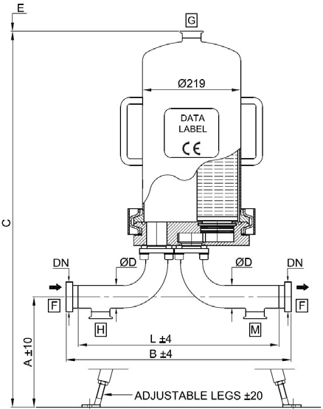

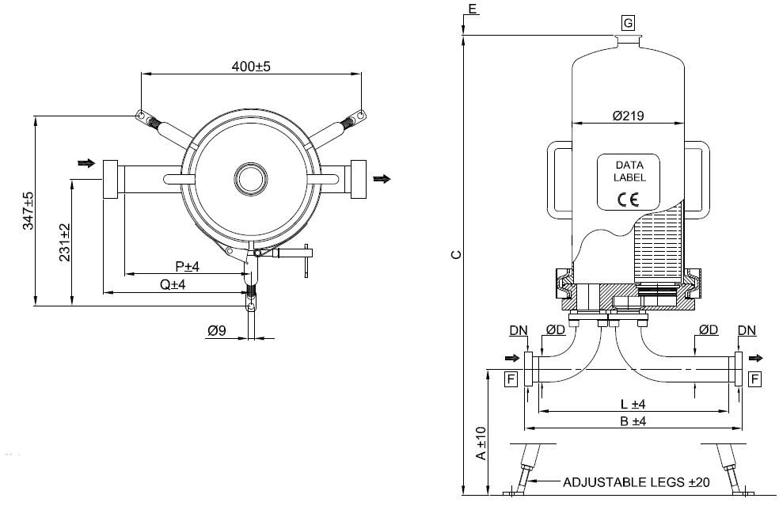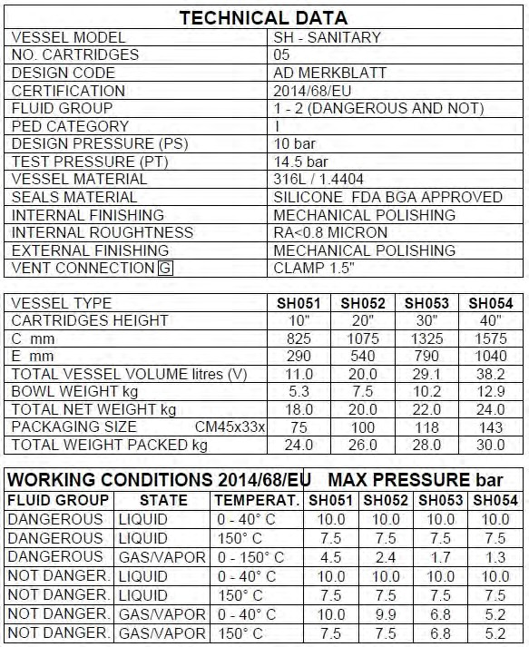

DIMENSIONAL DATA
CARTRIDGE x HEIGHT (N) | C mm | E mm | VOLUME liters (V) | PED Category | Fluid Group
05 x 10“ | 825 | 290 | 11 | II | 1 (dangerous)
05 x 20“ | 1075 | 540 | 20 | II | 1 (dangerous)
05 x 30“ | 1325 | 790 | 29.1 | III | 1 (dangerous)
05 x 40“ | 1575 | 1040 | 38.2 | III | 1 (dangerous)

CLAMP
 | WITHOUT DRAIN |  |  | WITH DRAIN
Dimension [mm] | A | B | Q | A | B | Q
1.5“ (38.1mm x 1.65mm) | 345 | 331 | 168 | 345 | 406 | 243
2.0“ (50.8mm x 1.65mm) | 315 | 379 | 196 | 315 | 446 | 263

DIN 11851 MALE PART
 | WITHOUT DRAIN |  |  | WITH DRAIN
Dimension [mm] | A | B | Q | A | B | Q
DN40 (38.1mm x 1.65mm) | 345 | 371 | 188 | 345 | 446 | 263
DN50 (50.8mm x 1.65mm) | 315 | 423 | 218 | 315 | 490 | 285

BUTT WELD ASME BPE
 | WITHOUT DRAIN |  |  | WITH DRAIN
Dimension [mm] | A | L | P | A | L | P
1.5“ (38.1mm x 1.65mm) | 345 | 305 | 155 | 345 | 380 | 230
2.0“ (50.8mm x 1.65mm) | 315 | 353 | 183 | 315 | 420 | 250

SMS MALE PART
 | WITHOUT DRAIN |  |  | WITH DRAIN
Dimension [mm] | A | B | Q | A | B | Q
1.5“ (38,1mm x 1.65mm) | 345 | 351 | 178 | 345 | 426 | 253
2.0“ (50.8mm x 1.65mm) | 315 | 403 | 208 | 315 | 470 | 275

Please Note
In filter housings with a flange connection at the in- and outlet e.g. DIN-EN1092-1, ANSI, etc. the bends will be welded directly to the baseplate, instead of the standard flange connection described in the detailed drawing.

ORDER CODE AND TECHNICAL EQUIPMENT
Order-no. | No. of Cartridges | Bowl Height | Connection | Nominal Diameter | Gasket | With Vent TC 1.5“ | With Drain TC 1.5“
 | 05 | 10“-40“ | DIN 11851 Male Part | DN 40 | Silicone | x | x
 | 05 | 10“-40“ | DIN 11851 Male Part | DN 40 | Silicone | x | -
 | 05 | 10“-40“ | DIN 11851 Male Part | DN 50 | Silicone | x | x
 | 05 | 10“-40“ | DIN 11851 Male Part | DN 50 | Silicone | x | -
 | 05 | 10“-40“ | TC | 1.5“ | Silicone | x | x
 | 05 | 10“-40“ | TC | 1.5“ | Silicone | x | -
 | 05 | 10“-40“ | TC | 2“ | Silicone | x | x
 | 05 | 10“-40“ | TC | 2“ | Silicone | x | -
 | 05 | 10“-40“ | Welding Stubs | 38.1 x 1.65 | Silicone | x | x
 | 05 | 10“-40“ | Welding Stubs | 38.1 x 1.65 | Silicone | x | -
 | 05 | 10“-40“ | Welding Stubs | 50.8 x 1.65 | Silicone | x | x
 | 05 | 10“-40“ | Welding Stubs | 50.8 x 1.65 | Silicone | x | -
 | 05 | 10“-40“ | SMS - Male part | 381. x 1.65 | Silicone | x | x
 | 05 | 10“-40“ | SMS - Male part | 381. x 1.65 | Silicone | x | -
 | 05 | 10“-40“ | SMS - Male part | 50.8 x 1.65 | Silicone | x | x
 | 05 | 10“-40“ | SMS - Male part | 50.8 x 1.65 | Silicone | x | -

„X“ = Placeholder for the bowl height:

1 = 10“
2 = 20“
3 = 30“
4 = 40“

SPARE PARTS
POS. | DESCRIPTION | MATERIAL | PART NO. | Q.TY
1 | HOUSING BOWL | AISI 316L |  | 1
2 | V-BAND | AISI 304 |  | 1
3 | CARTRIDGE PLATE | AISI 316L |  | 1
4 | O-RING d=5.35 ID=208.91 | SILICONE |  | 1
5 | GASKET CLAMP 2“ | PTFE |  | 2
6 | BEND FLANGE | AISI 304 |  | 4
7 | INLET BEND | AISI 316L |  | 1
8 | OUTLET BEND | AISI 316L |  | 1
9 | COMPLETE LEG | AISI 304 |  | 3
11 | PROTECTION PLATE | AISI 316L |  | 1

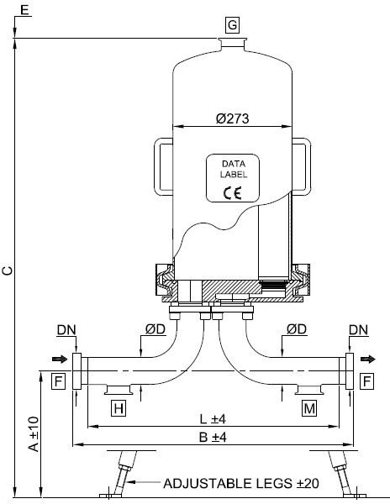

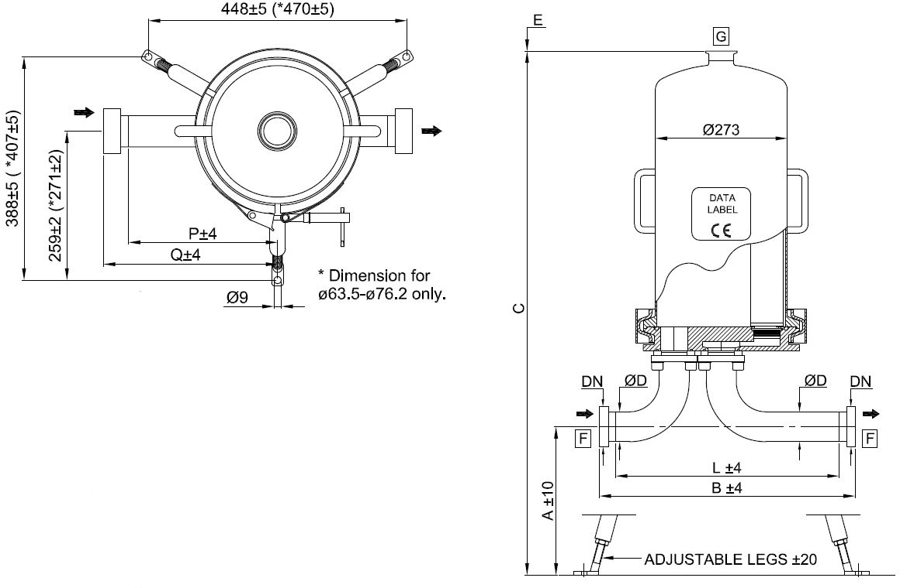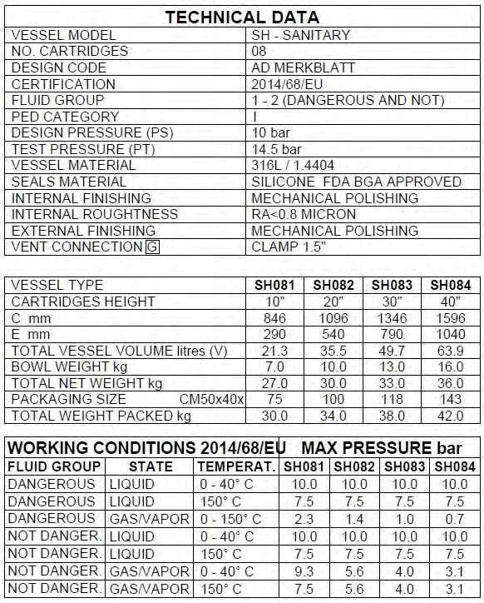

DIMENSIONAL DATA
CARTRIDGE x HEIGHT (N) | C mm | E mm | VOLUME liters (V) | PED Category | Fluid Group
08 x 10“ | 846 | 290 | 21.3 | III | 1 (dangerous)
08 x 20“ | 1096 | 540 | 35.5 | III | 1 (dangerous)
08 x 30“ | 1346 | 790 | 49.7 | III | 1 (dangerous)
08 x 40“ | 1596 | 1040 | 63.9 | III | 1 (dangerous)

CLAMP
 | WITHOUT DRAIN |  |  | WITH DRAIN
Dimension [mm] | A | B | Q | A | B | Q
1.5“ (38.1mm x 1.65mm) | 345 | 357 | 194 | 345 | 432 | 269
2.0“ (50.8mm x 1.65mm) | 315 | 405 | 222 | 315 | 472 | 289
2.5“ (63.5mm x 1.65mm) | 286 | 468 | 243 | 286 | 548 | 323
3.0“ (76.2mm x 1.65mm) | 258 | 524 | 271 | 258 | 604 | 351

DIN 11851 MALE PART
 | WITHOUT DRAIN |  |  | WITH DRAIN
Dimension [mm] | A | B | Q | A | B | Q
DN40 (38.1mm x 1.65mm) | 345 | 397 | 214 | 345 | 472 | 289
DN50 (50.8mm x 1.65mm) | 315 | 449 | 244 | 315 | 516 | 311
DN65 (63.5mm x 1.65mm) | 286 | 518 | 268 | 286 | 602 | 350
DN80 (76.2mm x 1.65mm) | 258 | 588 | 303 | 258 | 658 | 383

BUTT WELD ASME BPE
 | WITHOUT DRAIN |  |  | WITH DRAIN
Dimension [mm] | A | L | P | A | L | P
1.5“ (38.1mm x 1.65mm) | 345 | 331 | 181 | 345 | 406 | 256
2.0“ (50.8mm x 1.65mm) | 315 | 379 | 209 | 315 | 446 | 276
2.5“ (63.5mm x 1.65mm) | 286 | 442 | 230 | 286 | 522 | 310
3.0“ (76.2mm x 1.65mm) | 258 | 498 | 258 | 258 | 578 | 338

SMS - Male part
 | WITHOUT DRAIN |  |  | WITH DRAIN
Dimension [mm] | A | B | Q | A | B | Q
1.5“ (38.1mm x 1.65mm) | 345 | 377 | 204 | 345 | 452 | 279
2.0“ (50.8mm x 1.65mm) | 315 | 429 | 234 | 315 | 496 | 301
2.5“ (63.5mm x 1.65mm) | 286 | 502 | 260 | 286 | 582 | 340
3.0“ (76.2mm x 1.65mm) | 258 | 568 | 293 | 258 | 648 | 373

Please Note
In filter housings with a flange connection at the in- and outlet e.g. DIN-EN1092-1, ANSI, etc. the bends will be welded directly to the baseplate, instead of the standard flange connection described in the detailed drawing.

ORDER CODE AND TECHNICAL EQUIPMENT
Order-no. | No. of Cartridges | Bowl Height | Connection | Nominal Diameter | Gasket | With Vent TC 1.5“ | With Drain TC 1.5“
 | 08 | 10“-40“ | DIN 11851 Male Part | DN 40 | Silicone | x | x
 | 08 | 10“-40“ | DIN 11851 Male Part | DN 40 | Silicone | x | -
 | 08 | 10“-40“ | DIN 11851 Male Part | DN 50 | Silicone | x | x
 | 08 | 10“-40“ | DIN 11851 Male Part | DN 50 | Silicone | x | -
 | 08 | 10“-40“ | DIN 11851 Male Part | DN 65 | Silicone | x | x
 | 08 | 10“-40“ | DIN 11851 Male Part | DN 65 | Silicone | x | -
 | 08 | 10“-40“ | DIN 11851 Male Part | DN 80 | Silicone | x | x
 | 08 | 10“-40“ | DIN 11851 Male Part | DN 80 | Silicone | x | -
 | 08 | 10“-40“ | TC | 1.5“ | Silicone | x | x
 | 08 | 10“-40“ | TC | 1.5“ | Silicone | x | -
 | 08 | 10“-40“ | TC | 2“ | Silicone | x | x
 | 08 | 10“-40“ | TC | 2“ | Silicone | x | -
 | 08 | 10“-40“ | TC | 2.5“ | Silicone | x | x
 | 08 | 10“-40“ | TC | 2.5“ | Silicone | x | -
 | 08 | 10“-40“ | TC | 3.0“ | Silicone | x | x
 | 08 | 10“-40“ | TC | 3.0“ | Silicone | x | -
 | 08 | 10“-40“ | Welding Stubs | 38.1 x 1.65 | Silicone | x | x
 | 08 | 10“-40“ | Welding Stubs | 38.1 x 1.65 | Silicone | x | -
 | 08 | 10“-40“ | Welding Stubs | 50.8 x 1.65 | Silicone | x | x
 | 08 | 10“-40“ | Welding Stubs | 50.8 x 1.65 | Silicone | x | -
 | 08 | 10“-40“ | Welding Stubs | 63.5 x 1.65 | Silicone | x | x
 | 08 | 10“-40“ | Welding Stubs | 63.5 x 1.65 | Silicone | x | -
 | 08 | 10“-40“ | Welding Stubs | 76.2 x 1.65 | Silicone | x | x
 | 08 | 10“-40“ | Welding Stubs | 76.2 x 1.65 | Silicone | x | -
 | 08 | 10“-40“ | SMS - Male part | 38.1 x 1.65 | Silicone | x | x
 | 08 | 10“-40“ | SMS - Male part | 38.1 x 1.65 | Silicone | x | -
 | 08 | 10“-40“ | SMS - Male part | 50.8 x 1.65 | Silicone | x | x
 | 08 | 10“-40“ | SMS - Male part | 50.8 x 1.65 | Silicone | x | -
 | 08 | 10“-40“ | SMS - Male part | 63.5 x 1.65 | Silicone | x | x
 | 08 | 10“-40“ | SMS - Male part | 63.5 x 1.65 | Silicone | x | -
 | 08 | 10“-40“ | SMS - Male part | 76.2 x 1.65 | Silicone | x | x
 | 08 | 10“-40“ | SMS - Male part | 76.2 x 1.65 | Silicone | x | -

„X“ = Placeholder for the bowl height:

1 = 10“
2 = 20“
3 = 30“
4 = 40“

SPARE PARTS
POS. | DESCRIPTION | MATERIAL | PART NO. | Q.TY
1 | HOUSING BOWL | AISI 316L |  | 1
2 | V-BAND | AISI 304 |  | 1
3 | CARTRIDGE PLATE | AISI 316L |  | 1
4 | O-RING d=5.35 ID=266.06 | SILICONE |  | 1
5 | GASKET CLAMP | PTFE |  | 2
6 | BEND FLANGE | AISI 304 |  | 4
7 | INLET BEND | AISI 316L | - | 1
8 | OUTLET BEND | AISI 316L | - | 1
9 | COMPLETE LEG | AISI 304 | - | 3
11 | PROTECTION PLATE | AISI 316L | - | 1

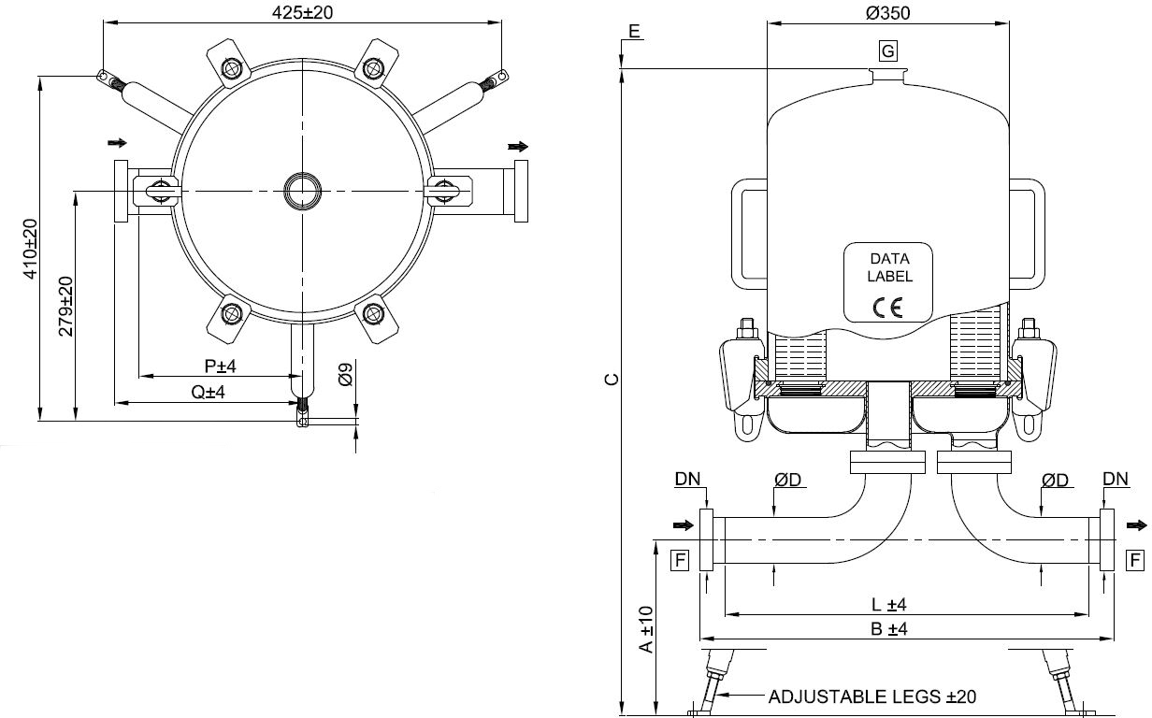
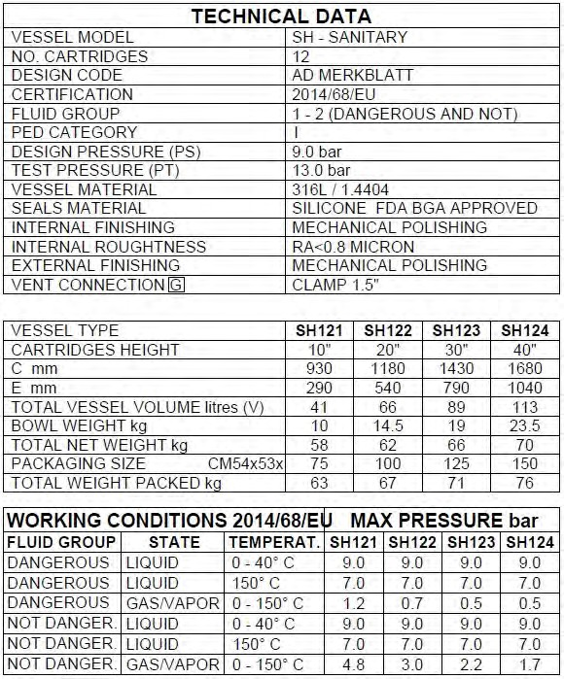
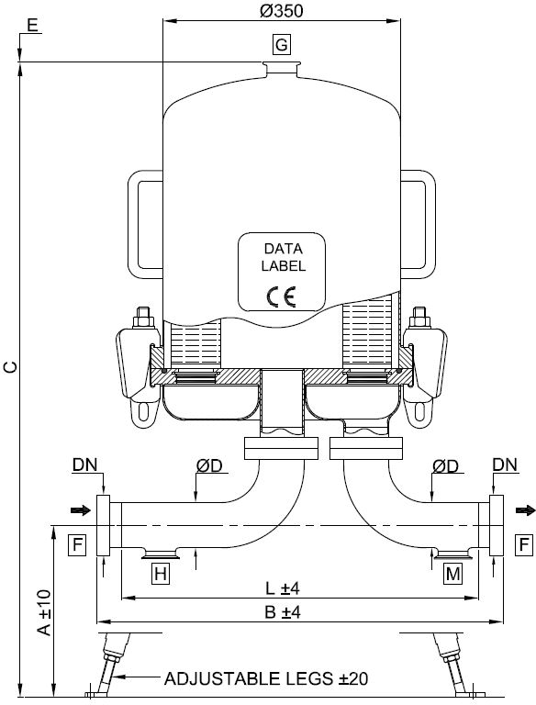

DIMENSIONAL DATA
CARTRIDGE x HEIGHT (N) | C mm | E mm | VOLUME liters (V) | PED Category | Fluid Group
12 x 10“ | 930 | 290 | 41 | III | 1 (dangerous)
12 x 20“ | 1180 | 540 | 66 | III | 1 (dangerous)
12 x 30“ | 1430 | 790 | 89 | III | 1 (dangerous)
12 x 40“ | 1680 | 1040 | 113 | IV | 1 (dangerous)

CLAMP
 | WITHOUT DRAIN |  |  | WITH DRAIN
Dimension [mm] | A | B | Q | A | B | Q
2.0“ (50.8mm x 1.65mm) | 350 | 474 | 238 | 350 | 544 | 238
2.5“ (63.5mm x 1.65mm) | 326 | 493 | 225 | 326 | 573 | 225
3.0“ (76.2mm x 1.65mm) | 298 | 549 | 253 | 298 | 629 | 253
4.0“ (101.6mm x 2mm) | 290 | 529 | 243 | 290 | 609 | 243

DIN 11851 MALE PART
 | WITHOUT DRAIN |  |  | WITH DRAIN
Dimension [mm] | A | B | Q | A | B | Q
DN50 (50.8mm x 1.65mm) | 350 | 519 | 258 | 350 | 586 | 258
DN65 (63.5mm x 1.65mm) | 326 | 547 | 252 | 326 | 627 | 252
DN80 (76.2mm x 1.65mm) | 297 | 603 | 280 | 297 | 683 | 280
DN100 (101.6mm x 2mm) | 290 | 527 | 202 | 290 | 687 | 282

BUTT WELD ASME BPE
 | WITHOUT DRAIN |  |  | WITH DRAIN
Dimension [mm] | A | L | P | A | L | P
2.0“ (50.8mm x 1.65mm) | 350 | 449 | 225 | 350 | 518 | 225
2.5“ (63.5mm x 1.65mm) | 326 | 467 | 212 | 326 | 547 | 212
3.0“ (76.2mm x 1.65mm) | 298 | 523 | 240 | 298 | 603 | 240
4.0“ (101.6mm x 2mm) | 290 | 483 | 210 | 290 | 583 | 230

SMS - Male part
 | WITHOUT DRAIN |  |  | WITH DRAIN
Dimension [mm] | A | B | Q | A | B | Q
2.0“ (50.8mm x 1.65mm) | 350 | 499 | 250 | 350 | 568 | 250
2.5“ (63.5mm x 1.65mm) | 326 | 527 | 242 | 326 | 607 | 242
3.0“ (76.2mm x 1.65mm) | 298 | 593 | 275 | 298 | 673 | 275
4.0“ (101.6mm x 2mm) | 290 | 543 | 240 | 290 | 643 | 260

ORDER CODE AND TECHNICAL EQUIPMENT
Order-no. | No. of Cartridges | Bowl Height | Connection | Nominal Diameter | Gasket | With Vent TC 1.5“ | With Drain TC 1.5“
 | 12 | 10“-40“ | DIN 11851 Male Part | DN 50 | Silicone | x | x
 | 12 | 10“-40“ | DIN 11851 Male Part | DN 50 | Silicone | x | -
 | 12 | 10“-40“ | DIN 11851 Male Part | DN 65 | Silicone | x | x
 | 12 | 10“-40“ | DIN 11851 Male Part | DN 65 | Silicone | x | -
 | 12 | 10“-40“ | DIN 11851 Male Part | DN 80 | Silicone | x | x
 | 12 | 10“-40“ | DIN 11851 Male Part | DN 80 | Silicone | x | -
 | 12 | 10“-40“ | DIN 11851 Male Part | DN 100 | Silicone | x | x
 | 12 | 10“-40“ | DIN 11851 Male Part | DN 100 | Silicone | x | -
 | 12 | 10“-40“ | TC | 2.0“ | Silicone | x | x
 | 12 | 10“-40“ | TC | 2.0“ | Silicone | x | -
 | 12 | 10“-40“ | TC | 2.5“ | Silicone | x | x
 | 12 | 10“-40“ | TC | 2.5“ | Silicone | x | -
 | 12 | 10“-40“ | TC | 3.0“ | Silicone | x | x
 | 12 | 10“-40“ | TC | 3.0“ | Silicone | x | -
 | 12 | 10“-40“ | TC | 4.0“ | Silicone | x | x
 | 12 | 10“-40“ | TC | 4.0“ | Silicone | x | -
 | 12 | 10“-40“ | Welding Stubs | 50.8 x 1.65 | Silicone | x | x
 | 12 | 10“-40“ | Welding Stubs | 50.8 x 1.65 | Silicone | x | -
 | 12 | 10“-40“ | Welding Stubs | 63.5 x 1.65 | Silicone | x | x
 | 12 | 10“-40“ | Welding Stubs | 63.5 x 1.65 | Silicone | x | -
 | 12 | 10“-40“ | Welding Stubs | 76.2 x 1.65 | Silicone | x | x
 | 12 | 10“-40“ | Welding Stubs | 76.2 x 1.65 | Silicone | x | -
 | 12 | 10“-40“ | Welding Stubs | 101.6 x 2.00 | Silicone | x | x
 | 12 | 10“-40“ | Welding Stubs | 101.6 x 2.00 | Silicone | x | -
 | 12 | 10“-40“ | SMS - Male part | 50.8 x 1.65 | Silicone | x | x
 | 12 | 10“-40“ | SMS - Male part | 50.8 x 1.65 | Silicone | x | -
 | 12 | 10“-40“ | SMS - Male part | 63.5 x 1.65 | Silicone | x | x
 | 12 | 10“-40“ | SMS - Male part | 63.5 x 1.65 | Silicone | x | -
 | 12 | 10“-40“ | SMS - Male part | 76.2 x 1.65 | Silicone | x | x
 | 12 | 10“-40“ | SMS - Male part | 76.2 x 1.65 | Silicone | x | -
 | 12 | 10“-40“ | SMS - Male part | 101.6 x 2.00 | Silicone | x | x
 | 12 | 10“-40“ | SMS - Male part | 101.6 x 2.00 | Silicone | x | -

„X“ = Placeholder for the bowl height:

1 = 10“
2 = 20“
3 = 30“
4 = 40“

SPARE PARTS
POS. | DESCRIPTION | MATERIAL | PART NO. | Q.TY
1 | HOUSING BOWL | AISI 316L | - | 1
2 | BOLT CLAMP M16 | AISI 316Ti
3 | O-RING d=7.00 ID=342.30 | SILICONE |  | 1
4 | CARTRIDGE PLATE | AISI 316L |  | 1
5 | LEG | AISI 304 |  | 3
6 | FOOT | AISI 304 |  | 3
7 | CLAMP 3“ | AISI 304 |  | 2
8.1 | GASKET CLAMP 3“ | PTFE |  | 2
8.2 | O-RING d=5.34 ID=100.00 | SILICONE | - | 2
9 | INLET BEND | AISI 316L | - | 1
10 | OUTLET BEND | AISI 316L | - | 1
11 | PROTECTION PLATE | AISI 316L | - | 1
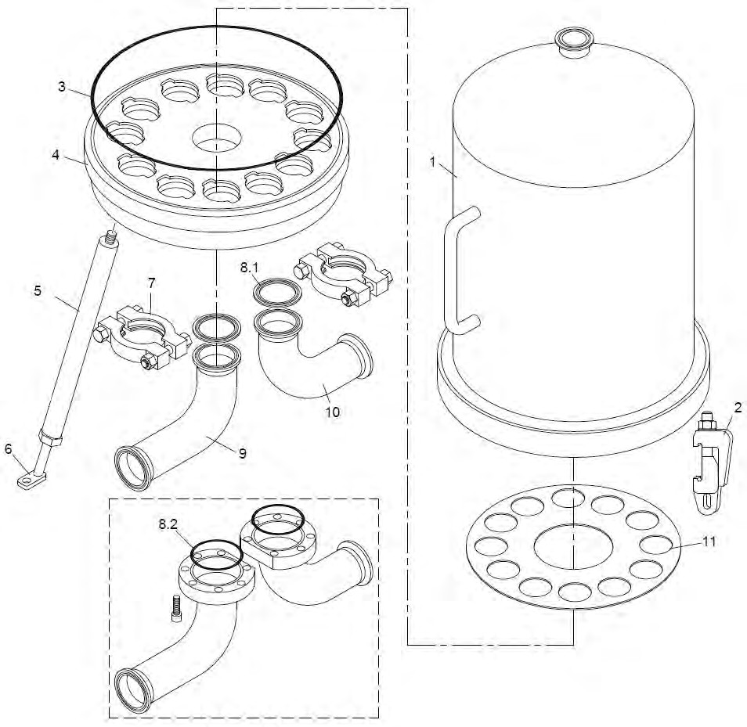

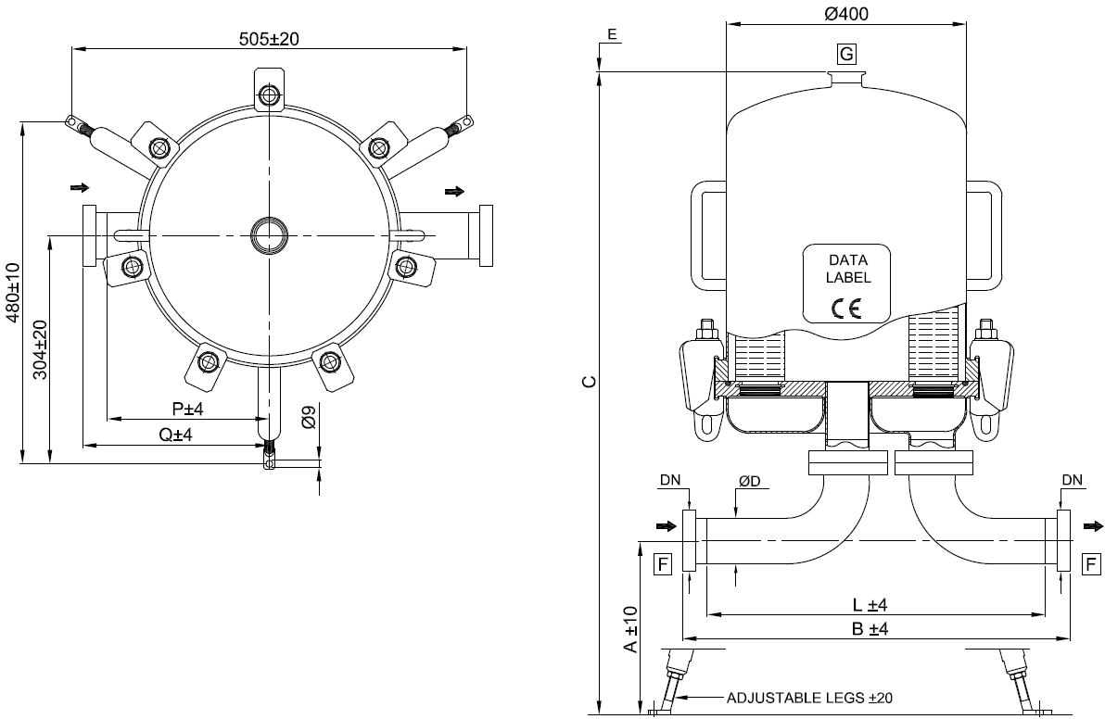

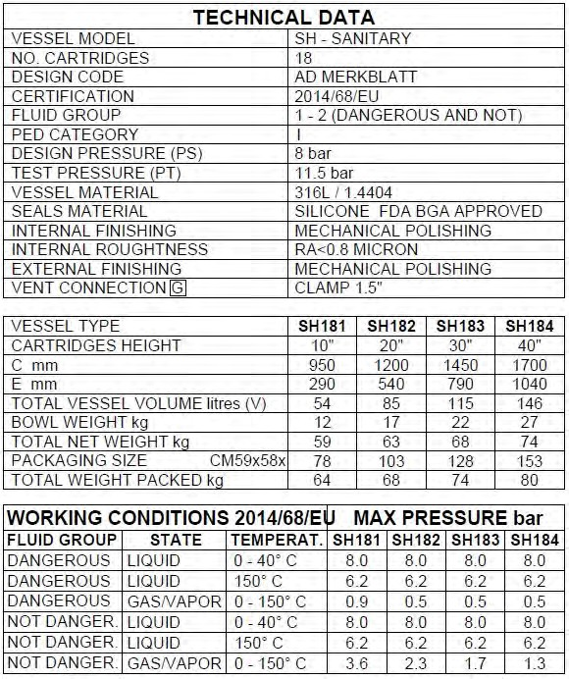
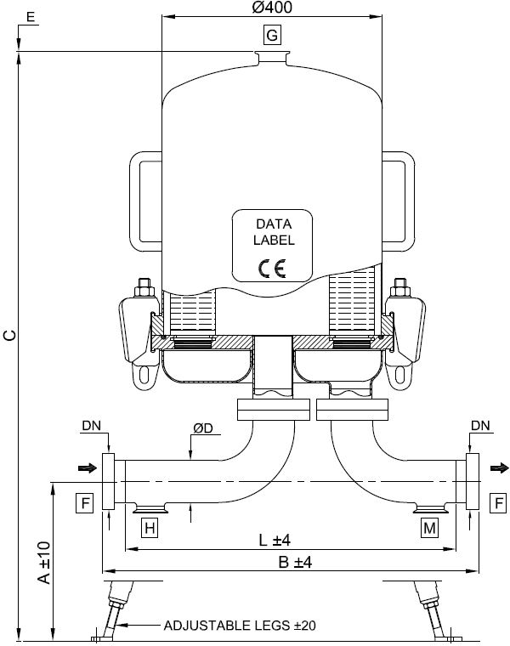

DIMENSIONAL DATA
CARTRIDGE x HEIGHT (N) | C mm | E mm | VOLUME liters (V) | PED Category | Fluid Group
18 x 10“ | 950 | 290 | 54 | III | 1 (dangerous)
18 x 20“ | 1200 | 540 | 85 | III | 1 (dangerous)
18 x 30“ | 1450 | 790 | 115 | III | 1 (dangerous)
18 x 40“ | 1700 | 1040 | 146 | IV | 1 (dangerous)

CLAMP
 | WITHOUT DRAIN |  |  | WITH DRAIN
Dimension [mm] | A | B | Q | A | B | Q
2.5“ (63.5mm x 1.65mm) | 325 | 509 | 225 | 325 | 589 | 225
3.0“ (76.2mm x 1.65mm) | 297 | 566 | 253 | 297 | 646 | 253
4.0“ (101.6mm x 2mm) | 287 | 552 | 246 | 287 | 632 | 246

DIN 11851 MALE PART
 | WITHOUT DRAIN |  |  | WITH DRAIN
Dimension [mm] | A | B | Q | A | B | Q
DN65 | 325 | 564 | 252 | 325 | 644 | 252
DN80 | 296 | 620 | 280 | 296 | 700 | 280
DN100 | 287 | 604 | 262 | 287 | 704 | 282

BUTT WELD ASME BPE
 | WITHOUT DRAIN |  |  | WITH DRAIN
Dimension [mm] | A | L | P | A | L | P
2.5“ (63.5mm x 1.65mm) | 325 | 484 | 212 | 325 | 564 | 212
3.0“ (76.2mm x 1.65mm) | 297 | 540 | 240 | 297 | 620 | 240
4.0“ (101.6mm x 2mm) | 292 | 604 | 314 | 292 | 600 | 230

SMS - Male part
 | WITHOUT DRAIN |  |  | WITH DRAIN
Dimension [mm] | A | B | Q | A | B | Q
2.5“ (63.5mm x 1.65mm) | 325 | 544 | 242 | 325 | 624 | 242
3.0“ (76.2mm x 1.65mm) | 297 | 610 | 275 | 297 | 690 | 275
4.0“ (101.6mm x 2mm) | 287 | 580 | 260 | 287 | 660 | 260

ORDER CODE AND TECHNICAL EQUIPMENT
Order-no. | No. of Cartridges | Bowl Height | Connection | Nominal Diameter | Gasket | With Vent TC 1.5“ | With Drain TC 1.5“
 | 18 | 10“-40“ | DIN 11851 Male Part | DN 65 | Silicone | x | x
 | 18 | 10“-40“ | DIN 11851 Male Part | DN 65 | Silicone | x | -
 | 18 | 10“-40“ | DIN 11851 Male Part | DN 80 | Silicone | x | x
 | 18 | 10“-40“ | DIN 11851 Male Part | DN 80 | Silicone | x | -
 | 18 | 10“-40“ | DIN 11851 Male Part | DN 100 | Silicone | x | x
 | 18 | 10“-40“ | DIN 11851 Male Part | DN 100 | Silicone | x | -
 | 18 | 10“-40“ | TC | 2.5“ | Silicone | x | x
 | 18 | 10“-40“ | TC | 2.5“ | Silicone | x | -
 | 18 | 10“-40“ | TC | 3.0“ | Silicone | x | x
 | 18 | 10“-40“ | TC | 3.0“ | Silicone | x | -
 | 18 | 10“-40“ | TC | 4.0“ | Silicone | x | x
 | 18 | 10“-40“ | TC | 4.0“ | Silicone | x | -
 | 18 | 10“-40“ | Welding Stubs | 63.5 x 1.65 | Silicone | x | x
 | 18 | 10“-40“ | Welding Stubs | 63.5 x 1.65 | Silicone | x | -
 | 18 | 10“-40“ | Welding Stubs | 76.2 x 1.65 | Silicone | x | x
 | 18 | 10“-40“ | Welding Stubs | 76.2 x 1.65 | Silicone | x | -
 | 18 | 10“-40“ | Welding Stubs | 101.6 x 2.00 | Silicone | x | x
 | 18 | 10“-40“ | Welding Stubs | 101.6 x 2.00 | Silicone | x | -
 | 18 | 10“-40“ | SMS - Male part | 63.5 x 1.65 | Silicone | x | x
 | 18 | 10“-40“ | SMS - Male part | 63.5 x 1.65 | Silicone | x | -
 | 18 | 10“-40“ | SMS - Male part | 76.2 x 1.65 | Silicone | x | x
 | 18 | 10“-40“ | SMS - Male part | 76.2 x 1.65 | Silicone | x | -
 | 18 | 10“-40“ | SMS - Male part | 101.6 x 2.00 | Silicone | x | x
 | 18 | 10“-40“ | SMS - Male part | 101.6 x 2.00 | Silicone | x | -

„X“ = Placeholder for the bowl height:

1 = 10“
2 = 20“
3 = 30“
4 = 40“

SPARE PARTS
POS. | DESCRIPTION | MATERIAL | PART NO. | Q.TY
1 | HOUSING BOWL | AISI 316L |  | 1
2 | BOLT CLAMP M16 | AISI 316Ti
3 | O-RING d=7.00 ID=393.10 | SILICONE |  | 1
4 | CARTRIDGE PLATE | AISI 316L |  | 1
5 | LEG | AISI 304 |  | 3
6 | FOOT | AISI 304 |  | 3
7 | CLAMP 3“ | AISI 304 |  | 2
8.1 | GASKET CLAMP 3“ | PTFE |  | 2
8.2 | O-RING d=5.34 ID=110.50 | SILICONE |  | 2
9 | INLET BEND | AISI 316L |  | 1
10 | OUTLET BEND | AISI 316L | - | 1
11 | PROTECTION PLATE | AISI 316L | - | 1
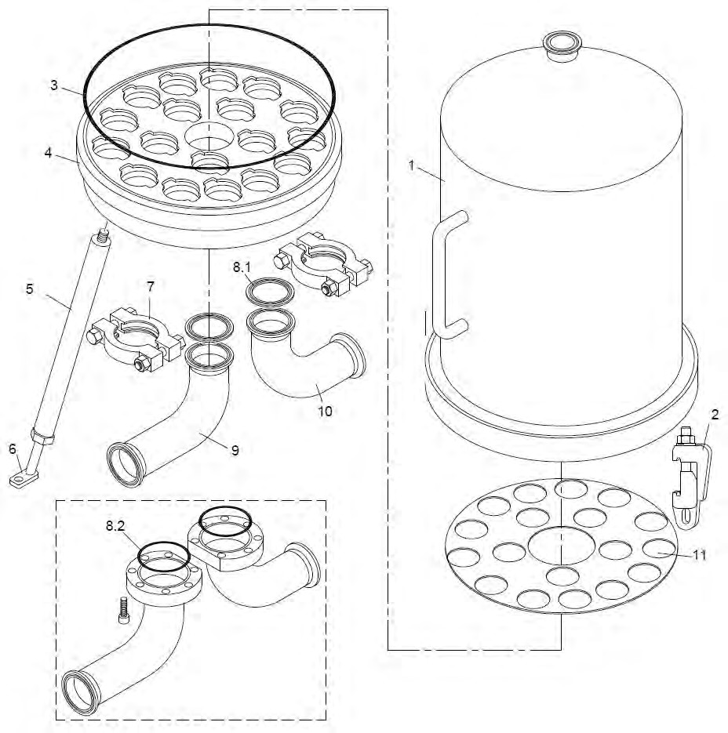

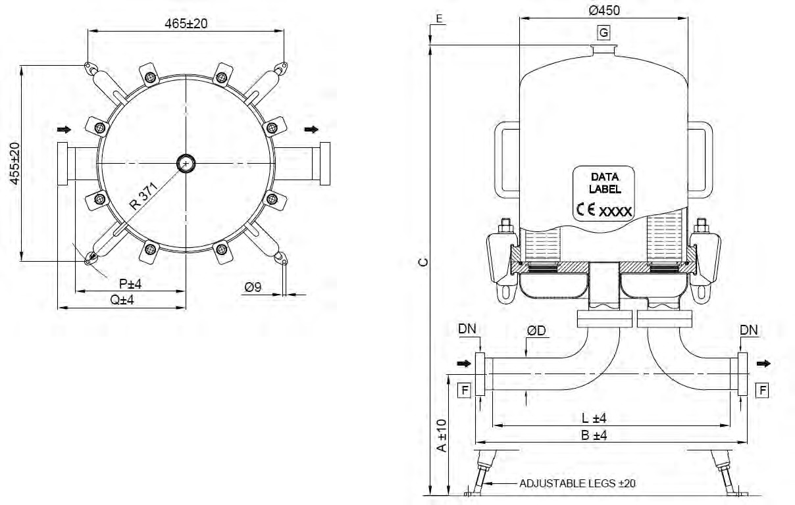
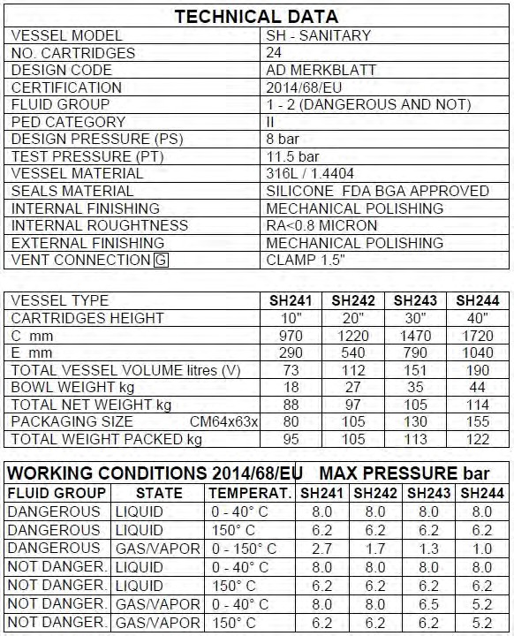
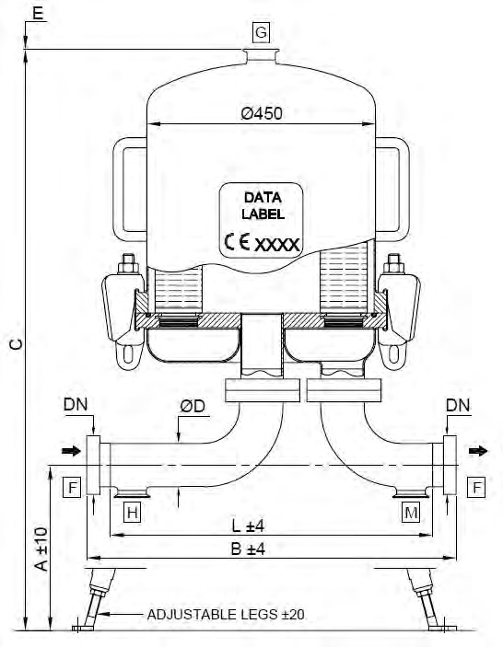

DIMENSIONAL DATA
CARTRIDGE x HEIGHT (N) | C mm | E mm | VOLUME liters (V) | PED Category | Fluid Group
24 x 10“ | 970 | 290 | 73 | III | 1 (dangerous)
24 x 20“ | 1220 | 540 | 112 | III | 1 (dangerous)
24 x 30“ | 1470 | 790 | 151 | IV | 1 (dangerous)
24 x 40“ | 1720 | 1040 | 190 | IV | 1 (dangerous)

CLAMP
 | WITHOUT DRAIN |  |  | WITH DRAIN
Dimension [mm] | A | B | Q | A | B | Q
2.5“ (63.5mm x 1.65mm) | 318 | 564 | 265 | 318 | 644 | 265
3.0“ (76.2mm x 1.65mm) | 292 | 580 | 253 | 292 | 660 | 253
4.0“ ( 101.6mm x 2.11mm) | 300 | 566 | 245 | 300 | 647 | 246

DIN 11851 MALE PART
 | WITHOUT DRAIN |  |  | WITH DRAIN
Dimension [mm] | A | B | Q | A | B | Q
DN65 (63.5mm x 1.65mm) | 318 | 618 | 292 | 318 | 698 | 292
DN80 (85mm x 2mm) | 331 | 616 | 296 | 331 | 696 | 296
DN100 (101.6mm x 2mm) | 300 | 638 | 281 | 300 | 718 | 296
DN125 (129.0mm x 2mm) | 253 | 701 | 314 | - | - | -

BUTT WELD ASME BPE
 | WITHOUT DRAIN |  |  | WITH DRAIN
Dimension [mm] | A | L | P | A | L | P
2.5“ (63.5mm x 1.65mm) | 318 | 538 | 252 | 318 | 618 | 252
3.0“ (76.2mm x 1.65mm) | 292 | 554 | 240 | 292 | 634 | 240
4.0“ (101.6mm x 2mm) | 300 | 534 | 229 | 300 | 614 | 230
5.0“ (139.7mm x 2.60mm) | 248 | 615 | 271 | - | - | -

SMS - Male part
 | WITHOUT DRAIN |  |  | WITH DRAIN
Dimension [mm] | A | B | Q | A | B | Q
2.5“ (63.5mm x 1.65mm) | 318 | 598 | 282 | 318 | 678 | 282
3.0“ (76.2mm x 1.65mm) | 292 | 624 | 275 | 292 | 704 | 275
4.0“ (101.6mm x 2mm) | 300 | 594 | 259 | 300 | 674 | 259

ORDER CODE AND TECHNICAL EQUIPMENT
Order-no. | No. of Cartridges | Bowl Height | Connection | Nominal Dia- meter | Gasket | With Vent TC 1.5“ | With Drain TC 1.5“
 | 24 | 10“-40“ | DIN 11851 Male Part | DN 65 | Silicone | x | x
 | 24 | 10“-40“ | DIN 11851 Male Part | DN 65 | Silicone | x | -
 | 24 | 10“-40“ | DIN 11851 Male Part | DN 80 | Silicone | x | x
 | 24 | 10“-40“ | DIN 11851 Male Part | DN 80 | Silicone | x | -
 | 24 | 10“-40“ | DIN 11851 Male Part | DN 100 | Silicone | x | x
 | 24 | 10“-40“ | DIN 11851 Male Part | DN 100 | Silicone | x | -
 | 24 | 10“-40“ | DIN 11851 Male Part | DN 125 | Silicone | x | -
 | 24 | 10“-40“ | TC | 2.5“ | Silicone | x | x
 | 24 | 10“-40“ | TC | 2.5“ | Silicone | x | -
 | 24 | 10“-40“ | TC | 3.0“ | Silicone | x | x
 | 24 | 10“-40“ | TC | 3.0“ | Silicone | x | -
 | 24 | 10“-40“ | TC | 4.0“ | Silicone | x | x
 | 24 | 10“-40“ | TC | 4.0“ | Silicone | x | -
 | 24 | 10“-40“ | Welding Stubs | 63.5 x 1.65 | Silicone | x | x
 | 24 | 10“-40“ | Welding Stubs | 63.5 x 1.65 | Silicone | x | -
 | 24 | 10“-40“ | Welding Stubs | 76.2 x 1.65 | Silicone | x | x
 | 24 | 10“-40“ | Welding Stubs | 76.2 x 1.65 | Silicone | x | -
 | 24 | 10“-40“ | Welding Stubs | 101.6 x 2.00 | Silicone | x | x
 | 24 | 10“-40“ | Welding Stubs | 101.6 x 2.00 | Silicone | x | -
 | 24 | 10“-40“ | Welding Stubs | 139.7 x 2.60 | Silicone | x | -
 | 24 | 10“-40“ | SMS - Male part | 63.5 x 1.65 | Silicone | x | x
 | 24 | 10“-40“ | SMS - Male part | 63.5 x 1.65 | Silicone | x | -
 | 24 | 10“-40“ | SMS - Male part | 76.2 x 1.65 | Silicone | x | x
 | 24 | 10“-40“ | SMS - Male part | 76.2 x 1.65 | Silicone | x | -
 | 24 | 10“-40“ | SMS - Male part | 101.6 x 2.00 | Silicone | x | x
 | 24 | 10“-40“ | SMS - Male part | 101.6 x 2.00 | Silicone | x | -

„X“ = Placeholder for the bowl height:

1 = 10“
2 = 20“
3 = 30“
4 = 40“

SPARE PARTS
POS. | DESCRIPTION | MATERIAL | PART NO. | Q.TY
1 | HOUSING BOWL | AISI 316L |  | 1
2 | BOLT CLAMP M16 | AISI 316Ti
3 | O-RING d=7.00 ID=443.40 | SILICONE |  | 1
4 | CARTRIDGE PLATE | AISI 316L |  | 1
5 | LEG | AISI 304 |  | 4
6 | FOOT | AISI 304 |  | 4
7 | CLAMP 4“ | AISI 304 |  | 2
8.1 | GASKET CLAMP 4“ | PTFE |  | 2
8.2 | O-RING d=5.34 ID=136.50 | SILICONE |  | 2
9 | INLET BEND | AISI 316L |  | 1
10 | OUTLET BEND | AISI 316L |  | 1
11 | PROTECTION PLATE | AISI 316L | - | 1
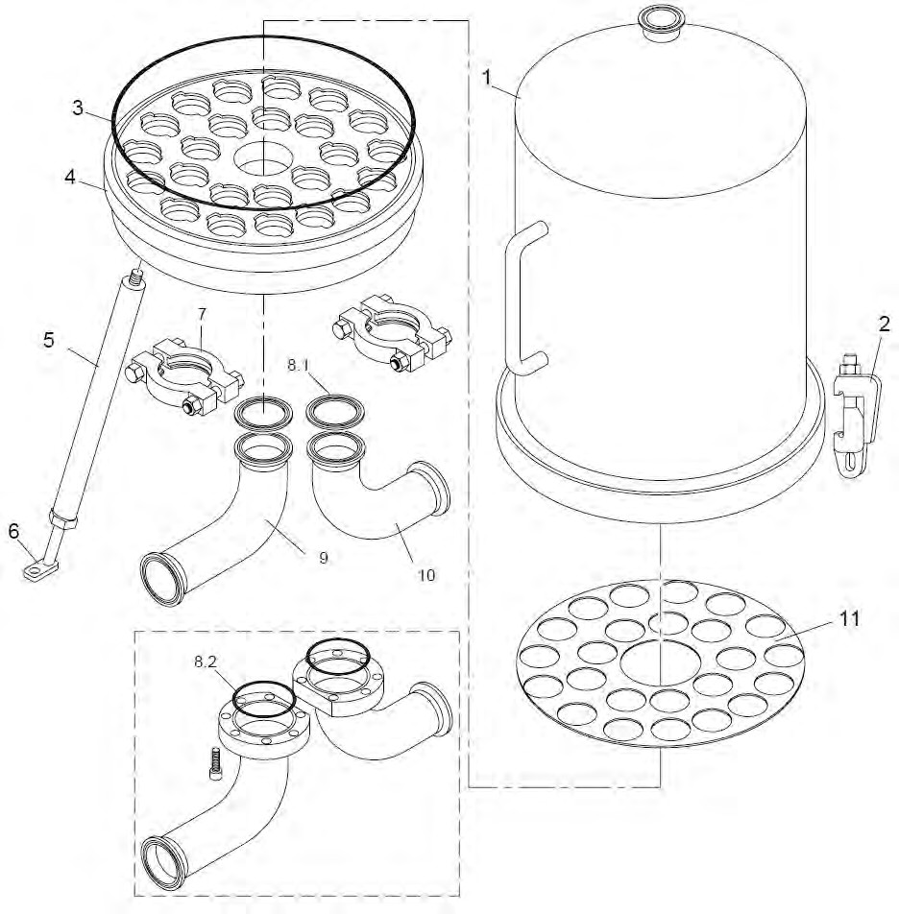

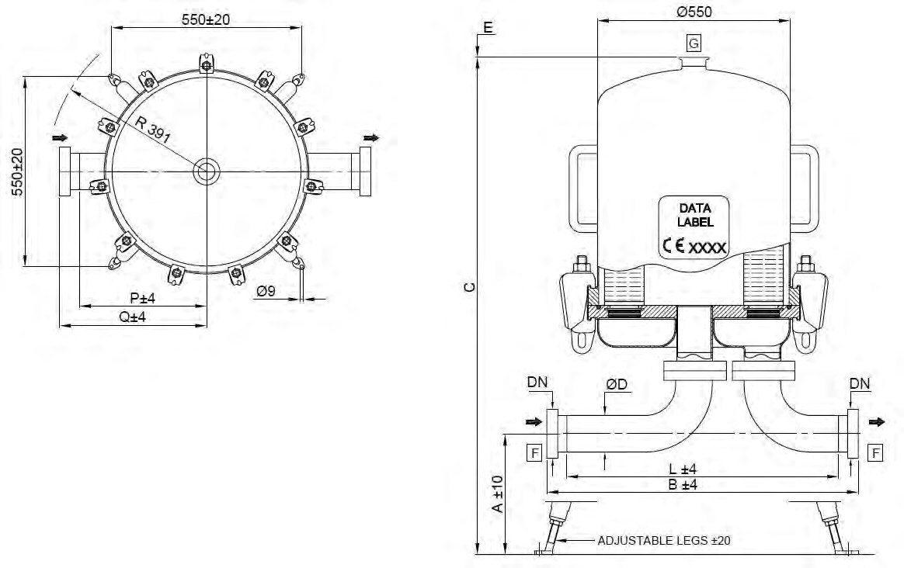
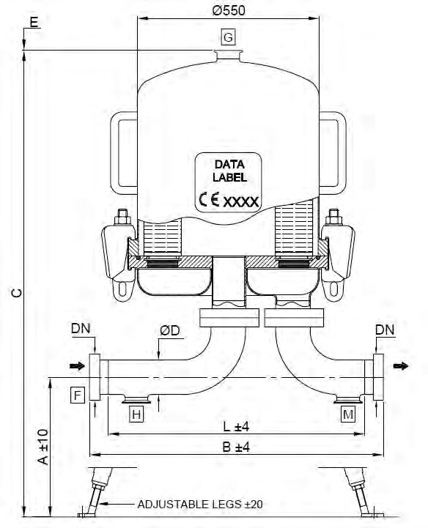
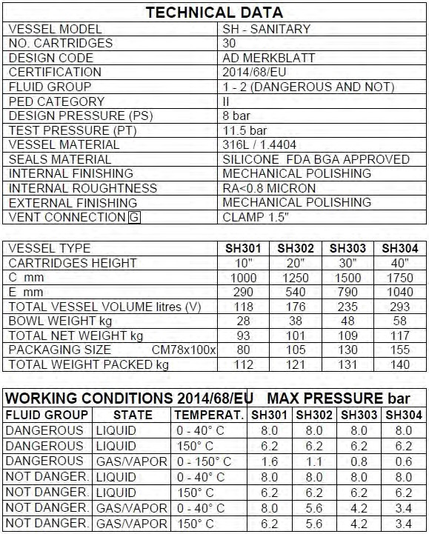

DIMENSIONAL DATA
CARTRIDGE x HEIGHT (N) | C mm | E mm | VOLUME liters (V) | PED Category | Fluid Group
30 x 10“ | 1000 | 290 | 118 | III | 1 (dangerous)
30 x 20“ | 1250 | 540 | 176 | III | 1 (dangerous)
30 x 30“ | 1500 | 790 | 235 | III | 1 (dangerous)
30 x 40“ | 1750 | 1040 | 293 | III | 1 (dangerous)

CLAMP
 | WITHOUT DRAIN |  |  | WITH DRAIN
Dimension [mm] | A | B | Q | A | B | Q
2.5“ (63.5mm x 1.65mm) | 318 | 665 | 330 | 318 | 745 | 330
3.0“ (76.2mm x 1.65mm) | 291 | 686 | 323 | 291 | 766 | 323
4.0“ ( 101.6mm x 2.11mm) | 300 | 662 | 306 | 300 | 742 | 306

DIN 11851 MALE PART
 | WITHOUT DRAIN |  |  | WITH DRAIN
Dimension [mm] | A | B | Q | A | B | Q
DN65 (63.5mm x 1.65mm) | 318 | 719 | 357 | 318 | 800 | 357
DN80 (85mm x 2mm) | 331 | 712 | 356 | 331 | 792 | 357
DN100 (101.6mm x 2mm) | 300 | 734 | 342 | 300 | 814 | 342
DN125 (129.0mm x 2mm) | 254 | 785 | 362 | - | - | -
DN150 (154.0mm x 2mm) | 218 | 820 | 355 | - | - | -

BUTT WELD ASME BPE
 | WITHOUT DRAIN |  |  | WITH DRAIN
Dimension [mm] | A | L | P | A | L | P
2.5“ (63.5mm x 1.65mm) | 318 | 639 | 317 | 318 | 719 | 317
3.0“ (76.2mm x 1.65mm) | 291 | 660 | 310 | 291 | 740 | 310
4.0“ (101.6mm x 2mm) | 300 | 630 | 290 | 300 | 710 | 290
5.0“ (139.7mm x 2.60mm) | 251 | 671 | 291 | - | - | -
6.0“ (168.3mm x 2.60mm) | 210 | 747 | 329 | - | - | -

SMS - Male part
 | WITHOUT DRAIN |  |  | WITH DRAIN
Dimension [mm] | A | B | Q | A | B | Q
2.5“ (63.5mm x 1.65mm) | 318 | 699 | 347 | 318 | 779 | 347
3.0“ (76.2mm x 1.65mm) | 291 | 730 | 345 | 291 | 810 | 345
4.0“ (101.6mm x 2mm) | 300 | 690 | 320 | 300 | 770 | 320

ORDER CODE AND TECHNICAL EQUIPMENT
Order-no. | No. of Cartridges | Bowl Height | Connection | Nominal Dia- meter | Gasket | With Vent TC 1.5“ | With Drain TC 1.5“
 | 30 | 10“-40“ | DIN 11851 Male Part | DN 65 | Silicone | x | x
 | 30 | 10“-40“ | DIN 11851 Male Part | DN 65 | Silicone | x | -
 | 30 | 10“-40“ | DIN 11851 Male Part | DN 80 | Silicone | x | x
 | 30 | 10“-40“ | DIN 11851 Male Part | DN 80 | Silicone | x | -
 | 30 | 10“-40“ | DIN 11851 Male Part | DN 100 | Silicone | x | x
 | 30 | 10“-40“ | DIN 11851 Male Part | DN 100 | Silicone | x | -
 | 30 | 10“-40“ | DIN 11851 Male Part | DN 125 | Silicone | x | -
 | 30 | 10“-40“ | DIN 11851 Male Part | DN 150 | Silicone | x | -
 | 30 | 10“-40“ | TC | 2.5“ | Silicone | x | x
 | 30 | 10“-40“ | TC | 2.5“ | Silicone | x | -
 | 30 | 10“-40“ | TC | 3.0“ | Silicone | x | x
 | 30 | 10“-40“ | TC | 3.0“ | Silicone | x | -
 | 30 | 10“-40“ | TC | 4.0“ | Silicone | x | x
 | 30 | 10“-40“ | TC | 4.0“ | Silicone | x | -
 | 30 | 10“-40“ | Welding Stubs | 63.5 x 1.65 | Silicone | x | x
 | 30 | 10“-40“ | Welding Stubs | 63.5 x 1.65 | Silicone | x | -
 | 30 | 10“-40“ | Welding Stubs | 76.2 x 1.65 | Silicone | x | x
 | 30 | 10“-40“ | Welding Stubs | 76.2 x 1.65 | Silicone | x | -
 | 30 | 10“-40“ | Welding Stubs | 101.6 x 2.00 | Silicone | x | x
 | 30 | 10“-40“ | Welding Stubs | 101.6 x 2.00 | Silicone | x | -
 | 30 | 10“-40“ | Welding Stubs | 139.7 x 2.60 | Silicone | x | -
 | 30 | 10“-40“ | Welding Stubs | 168.3 x 2.60 | Silicone | x | -
 | 30 | 10“-40“ | SMS - Male part | 63.5 x 1.65 | Silicone | x | x
 | 30 | 10“-40“ | SMS - Male part | 63.5 x 1.65 | Silicone | x | -
 | 30 | 10“-40“ | SMS - Male part | 76.2 x 1.65 | Silicone | x | x
 | 30 | 10“-40“ | SMS - Male part | 76.2 x 1.65 | Silicone | x | -
 | 30 | 10“-40“ | SMS - Male part | 101.6 x 2.00 | Silicone | x | x
 | 30 | 10“-40“ | SMS - Male part | 101.6 x 2.00 | Silicone | x | -

„X“ = Placeholder for the bowl height:

1 = 10“
2 = 20“
3 = 30“
4 = 40“

SPARE PARTS
POS. | DESCRIPTION | MATERIAL | PART NO. | Q.TY
1 | HOUSING BOWL | AISI 316L |  | 1
2 | BOLT CLAMP M16 | AISI 316Ti
3 | O-RING d=7.00 ID=532.30 | SILICONE |  | 1
4 | CARTRIDGE PLATE | AISI 316L |  | 1
5 | LEG | AISI 304 |  | 4
6 | FOOT | AISI 304 |  | 4
7 | CLAMP 4“ | AISI 304 |  | 2
8.1 | GASKET CLAMP 4“ | PTFE |  | 2
8.2 | O-RING d=5.34 ID=164.46 | SILICONE |  | 2
9 | INLET BEND | AISI 316L |  | 1
10 | OUTLET BEND | AISI 316L |  | 1
11 | PROTECTION PLATE | AISI 316L | - | 1
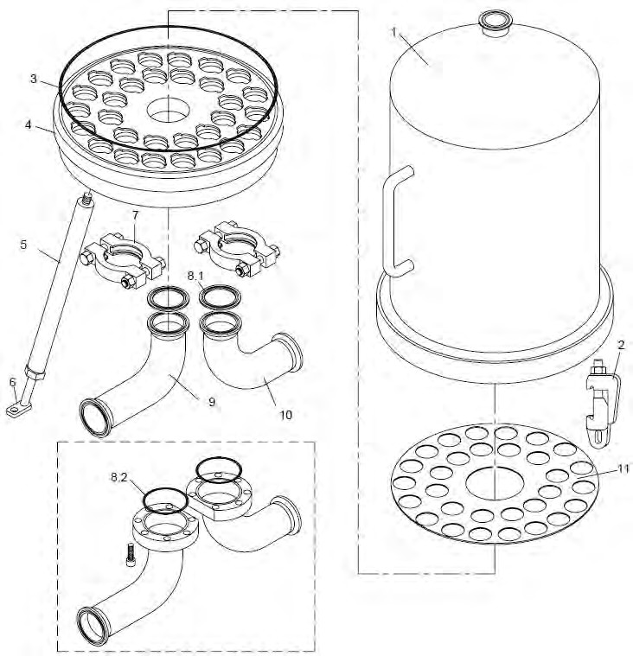

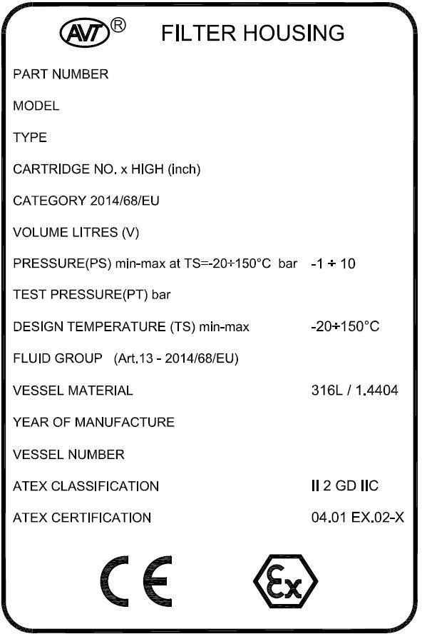
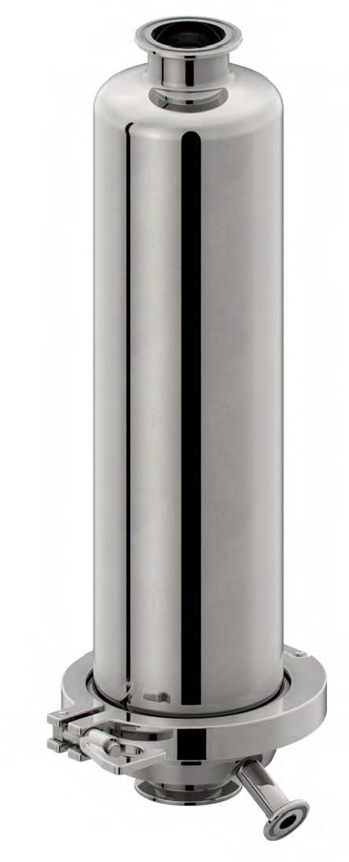

TECHNICHAL DATA
NO. CARTRIDGED | 01
CARTRIDGE SOCKET | 226 CODE 7
ATEX REGULATION | GROUP 2 - Cat 2 GASuDUST FLUID GR IIC zone 1u21
DESIGN CODE | DIN EN 13445
CERTIFICATION | PED 2014/68/EU
PED CATEGORY | 4.3
DESIGN PRESSURE | +10bar
DESIGN TEMPERATURE | -20°C...+150°C
VESSEL MATERIAL | 316L / 1.4404
FLUIDGROUP | 2 (not dangerous)
PHYSICAL STATE | LIQUID / GAS
INTERNAL FINISH | MECHANICAL POLISHING
INTERNAL ROUGHNESS | RA <0.8 MICRON
EXTERNAL FINISH | MECHANICAL POLISHING
INLET CONNECTION A | CLAMP ASME 1.5“ (38.1mm x 1.65xx)
OUTLET CONNECTION B | CLAMP ASME 1.5“ (38.1mm x 1.65xx)
DRAIN CONNECTION C | CLAMP ASME 0.5“ (12.7mm x 1.65xx)

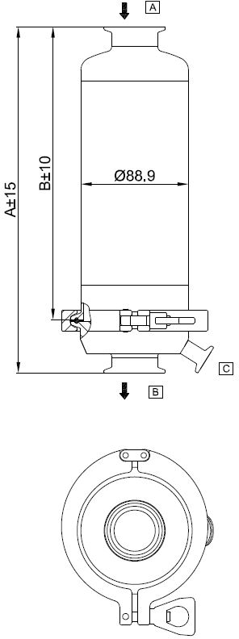
DIMENSIONAL DATA
CARTRIDGE x HEIGHT (N) | A mm | B mm | PED Category
01 x 05“ | 272 | 227 | 4.3
01 x 10“ | 375 | 333 | 4.3
01 x 20“ | 625 | 581 | 4.3
01 x 30“ | 875 | 831 | 4.3

SPARE PARTS
DESCRIPTION | MATERIAL | PART NO. | Q.TY
CLAMP 4“ | AISI 304 |  | 1
GASKET 4“ | SILICONE |  | 1
GASKET 4“ | EPDM |  | 1

ORDER CODE AND TECHNICAL EQUIPMENT
Order-no. | No. of Cartridges | Bowl Height | Connection Inlet u Outlet | Nominal Diameter | Gasket | With Drain TC 0.5“
 | 01 | 05“ | TC | 1.5“ | Silicone | x
 | 01 | 10“ | TC | 1.5“ | Silicone | x
 | 01 | 20“ | TC | 1.5“ | Silicone | x
 | 01 | 30“ | TC | 1.5“ | Silicone | x
 | 01 | 05“ | TC | 1.5“ | EPDM | x
 | 01 | 10“ | TC | 1.5“ | EPDM | x
 | 01 | 20“ | TC | 1.5“ | EPDM | x
 | 01 | 30“ | TC | 1.5“ | EPDM | x

Type 810 - Gas 1-round Housings
(10 bar Version)

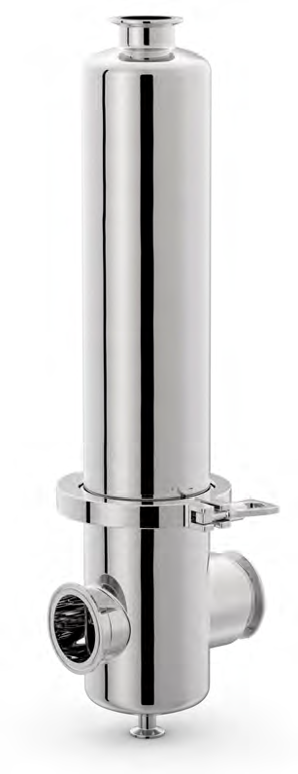

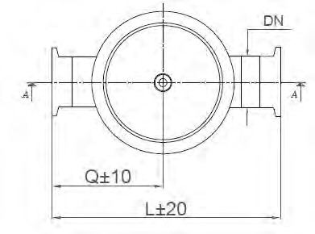
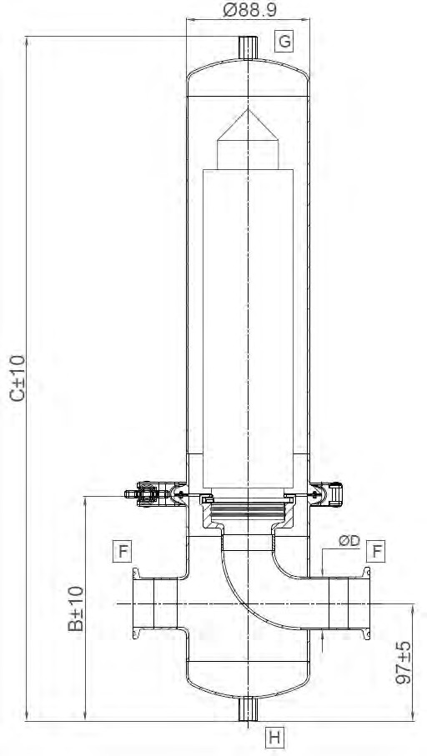
N±3

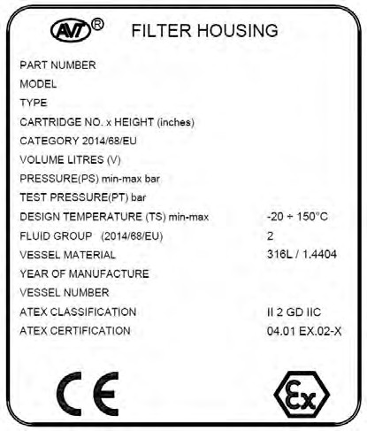

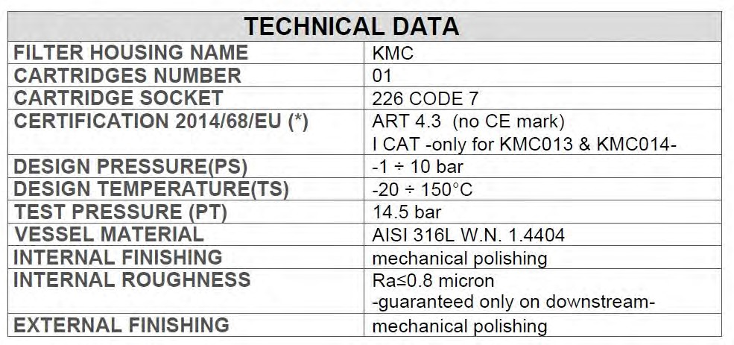

DIMENSIONAL DATA
CARTRIDGE x HEIGHT (N) | C [mm] with Vent u Drain BSPF 1/4“ female | C [mm] with Vent TC 1.5“ u Drain TC 0.5“ | B [mm] with Drain BSPF 1/4“ female | B [mm] with Drain TC 0.5“ | PED Category
01 x 5“ | 381 | 381 | 178 | 168 | 4.3
01 x 10“ | 501 | 501 | 178 | 168 | 4.3
01 x 20“ | 751 | 751 | 178 | 168 | 4.3
01 x 30“ | 1001 | 1001 | 178 | 168 | I
01 x 40“ | 1251 | 1251 | 178 | 168 | I

CLAMP
Dimension | L [mm] | Q [mm] | N [mm]
1.5“ (38.1mm x 1.65mm) | 129 | 62 | 99

DIN 11851 MALE PART
Dimension | L [mm] | Q [mm] | N [mm]
DN40 | 188 | 81 | 99

BUTT WELD ASME BPE
Dimension | L [mm] | Q [mm] | N [mm]
1.5“ (38.1mm x 1.65mm) | 264 | 129 | 99

PACKAGING SIZE AND WEIGHT
CARTRIDGE x HEIGHT (N) | BOWL WEIGHT [kg] | TOTAL NET WEIGHT [kg] | TOTAL WEIGHT PACKED [kg]
01 x 5“ | 0.7 | 2.6 | 3.6
01 x 10“ | 1.1 | 3.0 | 4.0
01 x 20“ | 1.9 | 4.0 | 5.0
01 x 30“ | 2.7 | 5.0 | 6.0
01 x 40“ | 3.5 | 6.0 | 7.0

ORDER CODE AND TECHNICAL EQUIPMENT
Order-no. | No. of Cartridges | Bowl Height | Connection | Nominal Diameter | Gasket | With Vent u Drain BSPF 1/4“ female [G/H] | With Vent TC 1.5“ u Drain TC 0.5“  [G/H]
 | 01 | 5“ | TC | 1.5“ | Silicone | x
 | 01 | 5“ | TC | 1.5“ | EPDM | x
 | 01 | 5“ | Welding Stubs | 1.5“ | Silicone | x
 | 01 | 5“ | Welding Stubs | 1.5“ | EPDM | x
 | 01 | 5“ | DIN 11851 Male Part | DN 40 | Silicone | x
 | 01 | 5“ | DIN 11851 Male Part | DN 40 | EPDM | x
 | 01 | 10“ | TC | 1.5“ | Silicone | x
 | 01 | 10“ | TC | 1.5“ | EPDM | x
 | 01 | 10“ | Welding Stubs | 1.5“ | Silicone | x
 | 01 | 10“ | Welding Stubs | 1.5“ | EPDM | x
 | 01 | 10“ | DIN 11851 Male Part | DN 40 | Silicone | x
 | 01 | 10“ | DIN 11851 Male Part | DN 40 | EPDM | x
 | 01 | 20“ | TC | 1.5“ | Silicone | x
 | 01 | 20“ | TC | 1.5“ | EPDM | x
 | 01 | 20“ | Welding Stubs | 1.5“ | Silicone | x
 | 01 | 20“ | Welding Stubs | 1.5“ | EPDM | x
 | 01 | 20“ | DIN 11851 Male Part | DN 40 | Silicone | x
 | 01 | 20“ | DIN 11851 Male Part | DN 40 | EPDM | x
 | 01 | 30“ | TC | 1.5“ | Silicone | x
 | 01 | 30“ | TC | 1.5“ | EPDM | x
 | 01 | 30“ | Welding Stubs | 1.5“ | Silicone | x
 | 01 | 30“ | Welding Stubs | 1.5“ | EPDM | x
 | 01 | 30“ | DIN 11851 Male Part | DN 40 | Silicone | x
 | 01 | 30“ | DIN 11851 Male Part | DN 40 | EPDM | x
 | 01 | 40“ | TC | 1.5“ | Silicone | x
 | 01 | 40“ | TC | 1.5“ | EPDM | x
 | 01 | 40“ | Welding Stubs | 1.5“ | Silicone | x
 | 01 | 40“ | Welding Stubs | 1.5“ | EPDM | x
 | 01 | 40“ | DIN 11851 Male Part | DN 40 | Silicone | x
 | 01 | 40“ | DIN 11851 Male Part | DN 40 | EPDM | x
 | 01 | 5“ | TC | 1.5“ | Silicone |  | x
 | 01 | 5“ | TC | 1.5“ | EPDM |  | x
 | 01 | 10“ | TC | 1.5“ | Silicone |  | x
 | 01 | 10“ | TC | 1.5“ | EPDM |  | x
 | 01 | 20“ | TC | 1.5“ | Silicone |  | x
 | 01 | 20“ | TC | 1.5“ | EPDM |  | x
 | 01 | 30“ | TC | 1.5“ | Silicone |  | x
 | 01 | 30“ | TC | 1.5“ | EPDM |  | x
 | 01 | 40“ | TC | 1.5“ | Silicone |  | x
 | 01 | 40“ | TC | 1.5“ | EPDM |  | x

SPARE PARTS
POS. | DESCRIPTION | MATERIAL | PART NO. | Q.TY
1 | HOUSING BOWL | AISI 316L |  | 1
2 | CLAMP 3.5“ | AISI 304 |  | 1
4 | GASKET CLAMP 3.5“ | SILICONE |  | 1
4 | GASKET CLAMP 3.5“ | EPDM |  | 1

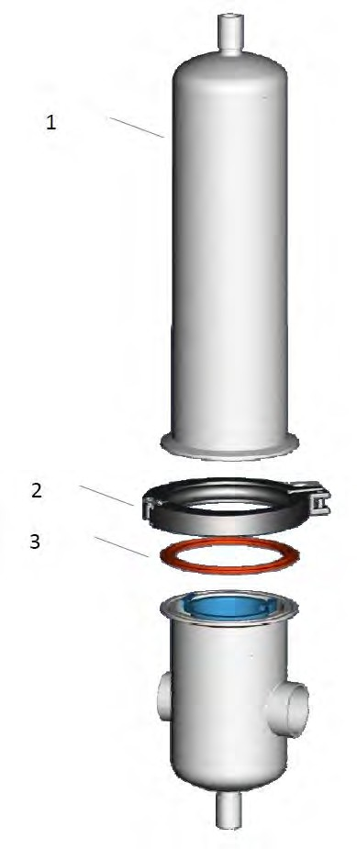

Type 805 - Gas Multi-round Housings

(5 bar Version)
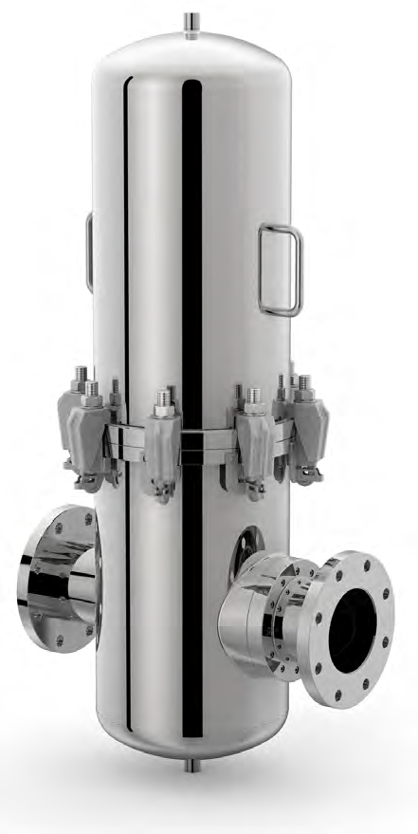

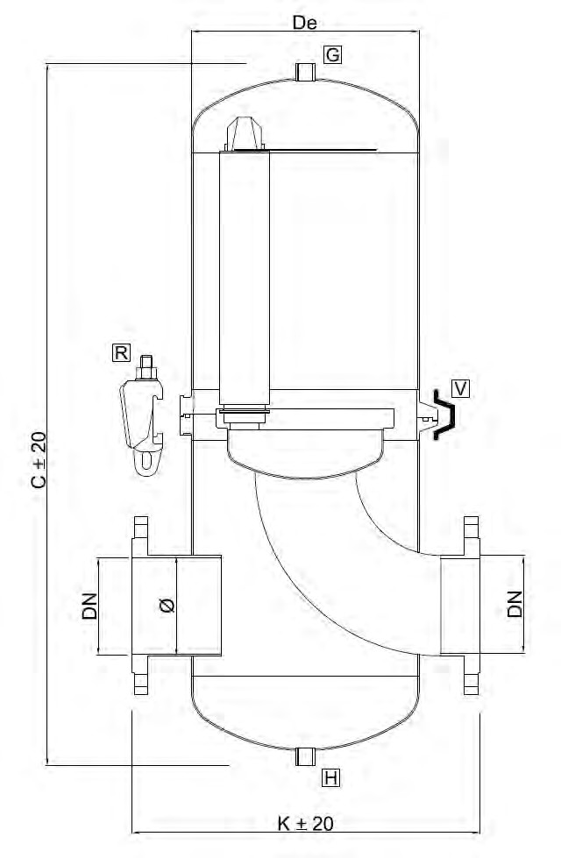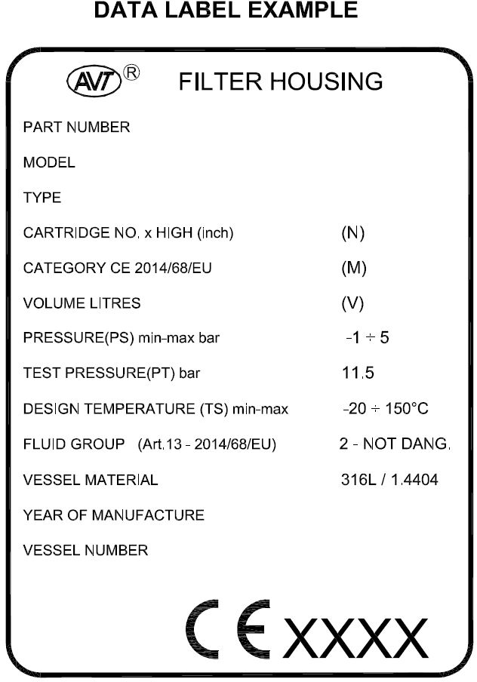
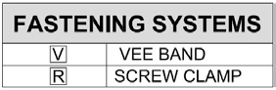
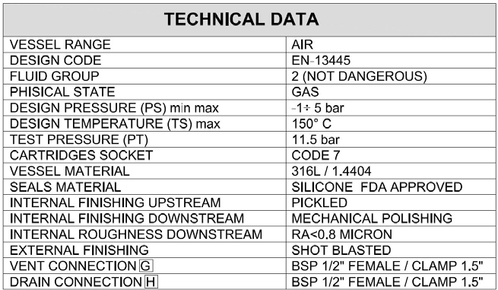

DIMENSIONAL DATA
CARTRIDGE x HEIGHT (N) | FASTENING SYTEM | De [mm] | C  [mm] | K [mm] | CONNECTIONS DN  max / ∅ max mm | TOTAL VOLUME [L] | PED Category
03 x 10“ | V  V  R | 219  273  320 | 829 | 443  511  515 | DN 100 / ∅ 114.3mm  DN 125 / ∅ 139.7mm DN 125 / ∅ 139.7mm | 33 | I
03 x 20“ | V  V  R | 219  273  320 | 1079 | 443  511  515 | DN 100 / ∅ 114.3mm  DN 125 / ∅ 139.7mm DN 125 / ∅ 139.7mm | 42 | II
05 x 10“ | V  V  R | 219  273  320 | 875 | 443  511  515 | DN 100 / ∅ 114.3mm  DN 125 / ∅ 139.7mm DN 125 / ∅ 139.7mm | 46 | II
05 x 20“ | V  V  R | 219  273  320 | 1125 | 443  511  515 | DN 100 / ∅ 114.3mm  DN 125 / ∅ 139.7mm DN 125 / ∅ 139.7mm | 61 | II
08 x 10“ | V  V  R | 219  273  320 | 935 | 443  511  515 | DN 100 / ∅ 114.3mm  DN 125 / ∅ 139.7mm DN 125 / ∅ 139.7mm | 59 | II
08 x 20“ | V  V  R | 219  273  320 | 1175 | 443  511  515 | DN 100 / ∅ 114.3mm  DN 125 / ∅ 139.7mm DN 125 / ∅ 139.7mm | 82 | II

ORDER CODE AND TECHNICAL EQUIPMENT
Order-no. | No. of Cartridges | Bowl Heigh t | Connection | Nominal Diameter | Gasket | With Vent u Drain BSPF 1/2“  female | With Vent u Drain TC 1.5“ | Standard
 | 03 | 10“ | FLANGE DIN EN 1092-1 | DN 100 | Silicone | x |  | x
 | 03 | 10“ | FLANGE DIN EN 1092-1 | DN 100 | EPDM | x
 | 03 | 20“ | FLANGE DIN EN 1092-1 | DN 100 | Silicone | x |  | x
 | 03 | 20“ | FLANGE DIN EN 1092-1 | DN 100 | EPDM | x
 | 05 | 10“ | FLANGE DIN EN 1092-1 | DN 125 | Silicone | x |  | x
 | 05 | 10“ | FLANGE DIN EN 1092-1 | DN 125 | EPDM | x
 | 05 | 20“ | FLANGE DIN EN 1092-1 | DN 125 | Silicone | x |  | x
 | 05 | 20“ | FLANGE DIN EN 1092-1 | DN 125 | EPDM | x
 | 08 | 10“ | FLANGE DIN EN 1092-1 | DN 125 | Silicone | x |  | x
 | 08 | 10“ | FLANGE DIN EN 1092-1 | DN 125 | EPDM | x
 | 08 | 20“ | FLANGE DIN EN 1092-1 | DN 125 | Silicone | x |  | x
 | 08 | 20“ | FLANGE DIN EN 1092-1 | DN 125 | EPDM | x
 | 03 | 10“ | FLANGE DIN EN 1092-1 | DN 100 | Silicone |  | x | x
 | 03 | 10“ | FLANGE DIN EN 1092-1 | DN 100 | EPDM |  | x
 | 03 | 20“ | FLANGE DIN EN 1092-1 | DN 100 | Silicone |  | x | x
 | 03 | 20“ | FLANGE DIN EN 1092-1 | DN 100 | EPDM |  | x
 | 05 | 10“ | FLANGE DIN EN 1092-1 | DN 125 | Silicone |  | x | x
 | 05 | 10“ | FLANGE DIN EN 1092-1 | DN 125 | EPDM |  | x
 | 05 | 20“ | FLANGE DIN EN 1092-1 | DN 125 | Silicone |  | x | x
 | 05 | 20“ | FLANGE DIN EN 1092-1 | DN 125 | EPDM |  | x
 | 08 | 10“ | FLANGE DIN EN 1092-1 | DN 125 | Silicone |  | x | x
 | 08 | 10“ | FLANGE DIN EN 1092-1 | DN 125 | EPDM |  | x
 | 08 | 20“ | FLANGE DIN EN 1092-1 | DN 125 | Silicone |  | x | x
 | 08 | 20“ | FLANGE DIN EN 1092-1 | DN 125 | EPDM |  | x
OTHER SIZES ON REQUEST

Type 808 - industrial
- round - liquid housing
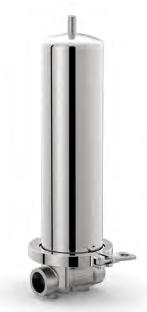

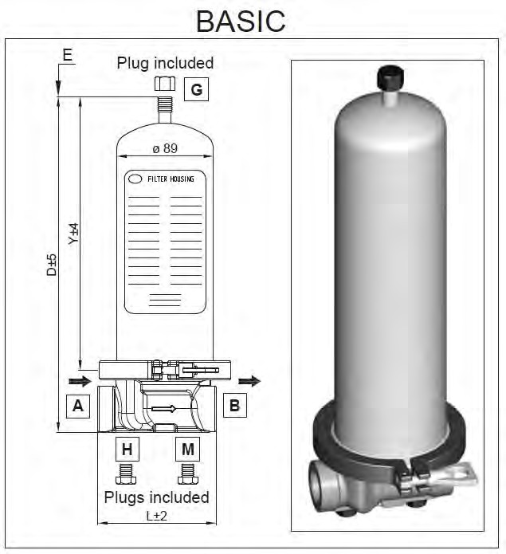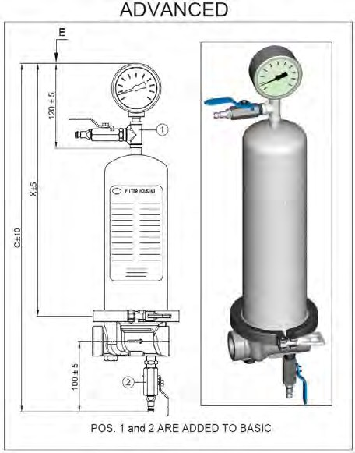
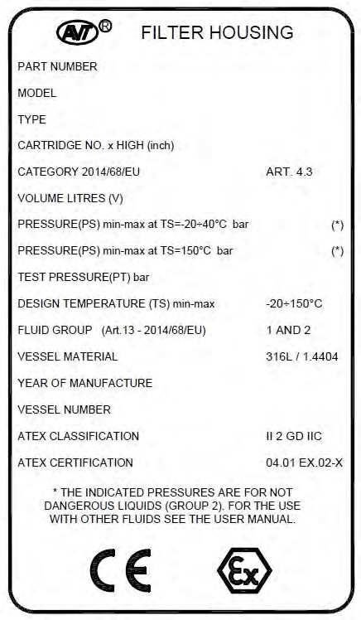
TECHNICHAL DATA
NO. CARTRIDGED | 01
CARTRIDGE SOCKET | 25 (Code 7)
CERTIFICATION | PED 2014/68/EU - art. 4 / sec. 3
FLUID GROUP | GROUP 2 (not dangerous)
DESIGN PRESSURE 0°C-40°C | 8.0 bar
DESIGN PRESSURE 150°C | 6.2 bar
TEST PRESSURE (PT) | 10.5 bar
VESSEL MATERIAL | 316L / 1.4404
GASKET | SILICONE
INTERNAL FINISHING | PICKLED
INTERNAL FINISHING | MECHANICAL POLISHING
DRAIN CONNECTION H + M | BSP 1/4“ FEMALE
VENT CONNECTION G | BSP 1/4“ MALE
DISTANCE L (ADAPTER 25 - CODE 7) | 110 mm
DISTANCE L (ADAPTER 21 - CODE 8) | 98 mm

DIMENSIONAL DATA
CARTRIDGE x HEIGHT (Y) | C mm | D mm | E mm | X mm | Y mm | VOLUME liters (V) | BOWL WEIGHT (kg) | TOTAL NET WEIGHT (kg)
01 x 10“ | 572 | 382 | 300 | 440 | 320 | 1.8 | 1.1 | 4
01 x 20“ | 827 | 637 | 554 | 695 | 575 | 3.3 | 1.9 | 4.8
01 x 30“ | 1082 | 892 | 808 | 950 | 830 | 4.8 | 2.7 | 5.6
01 x 40“ | 1337 | 1147 | 1062 | 1205 | 1085 | 6.3 | 3.5 | 6.4

ORDER CODE AND TECHNICAL EQUIPMENT
Order-no. | No. of Cartridges | Bowl Height | Adapter | Version | Connection Inlet u Outlet | Gasket
 | 01 | 10“ | 25 (Code 7) | ADVANCED | BSP 3/4“ FEMALE | Silicone
 | 01 | 20“ | 25 (Code 7) | ADVANCED | BSP 3/4“ FEMALE | Silicone
 | 01 | 30“ | 25 (Code 7) | ADVANCED | BSP 3/4“ FEMALE | Silicone
 | 01 | 10“ | 25 (Code 7) | ADVANCED | BSP 1“ FEMALE | Silicone
 | 01 | 20“ | 25 (Code 7) | ADVANCED | BSP 1“ FEMALE | Silicone
 | 01 | 30“ | 25 (Code 7) | ADVANCED | BSP 1“ FEMALE | Silicone
 | 01 | 10“ | 21 (Code 8) | ADVANCED | BSP 3/4“ FEMALE | Silicone
 | 01 | 20“ | 21 (Code 8) | ADVANCED | BSP 3/4“ FEMALE | Silicone
 | 01 | 30“ | 21 (Code 8) | ADVANCED | BSP 3/4“ FEMALE | Silicone
 | 01 | 10“ | 21 (Code 8) | ADVANCED | BSP 1“ FEMALE | Silicone
 | 01 | 20“ | 21 (Code 8) | ADVANCED | BSP 1“ FEMALE | Silicone
 | 01 | 30“ | 21 (Code 8) | ADVANCED | BSP 1“ FEMALE | Silicone

Type 800 - Vent Housings

(Pressureless)

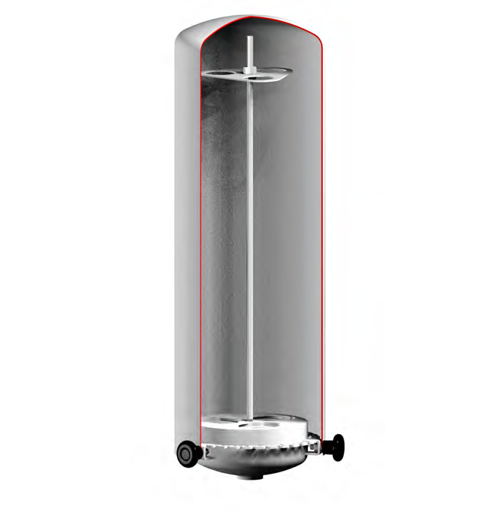

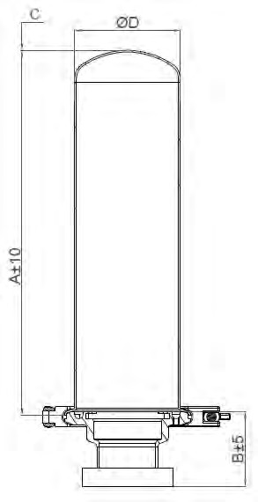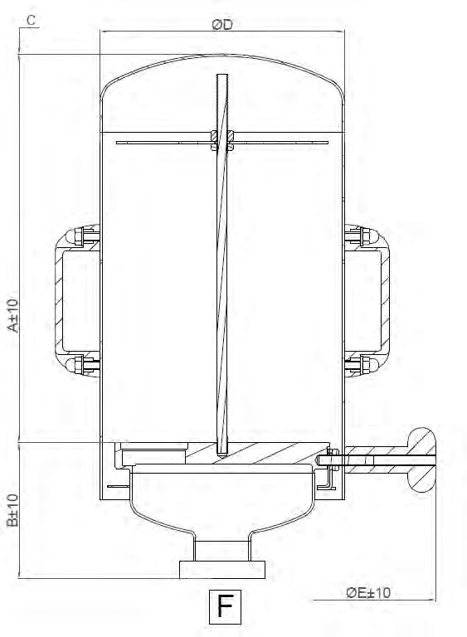
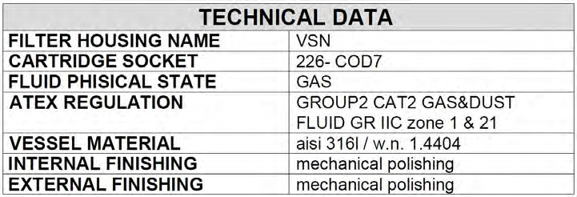

DIMENSIONAL DATA
CARTRIDGE x HEIGHT (N) | A [mm] | B [mm] |  | C [mm]  (height needed for removing the bell over the cartris- ges) | D [mm] | E [mm] | HANDLES
CARTRIDGE x HEIGHT (N) | A [mm] | CLAMP ASME BPE | DIN 11851 LINER
01 x 10“ | 315 | 43 | 59 | 300 | 88.9 | 130 | NO
01 x 20“ | 565 | 43 | 59 | 550 | 88.9 | 130 | NO
01 x 30“ | 815 | 43 | 59 | 800 | 88.9 | 130 | NO
03 x 10“ | 351 | 97 | 127 | 300 | 219 | 400 | NO
03 x 20“ | 601 | 97 | 127 | 550 | 219 | 400 | YES
03 x 30“ | 851 | 97 | 127 | 800 | 219 | 400 | YES
05 x 10“ | 345 | 106 | 133 | 300 | 219 | 400 | NO
05 x 20“ | 595 | 106 | 133 | 550 | 219 | 400 | YES
05 x 30“ | 845 | 106 | 133 | 800 | 219 | 400 | YES
08 x 10“ | 349 | 120 | 147 | 300 | 273 | 440 | NO
08 x 20“ | 599 | 120 | 147 | 550 | 273 | 440 | YES
08 x 30“ | 849 | 120 | 147 | 800 | 273 | 440 | YES

ORDER CODE AND TECHNICAL EQUIPMENT
Order-no. | No. of Cartridges | Bowl Height | Connection Type Nominal Diameter / Size
 |  |  | Clamp ASME BPE | DIN 11851 Liner
 | 01 | 10“ | 2“ (50.8mm x 1.65mm)
 | 01 | 20“ | 2“ (50.8mm x 1.65mm)
 | 01 | 30“ | 2“ (50.8mm x 1.65mm)
 | 03 | 10“ | 3“ (76.2mm x 1.65mm)
 | 03 | 20“ | 3“ (76.2mm x 1.65mm)
 | 03 | 30“ | 3“ (76.2mm x 1.65mm)
 | 05 | 10“ | 4“ (101.2mm x 2.11mm)
 | 05 | 20“ | 4“ (101.2mm x 2.11mm)
 | 05 | 30“ | 4“ (101.2mm x 2.11mm)
 | 08 | 10“ | 4“ (101.2mm x 2.11mm)
 | 08 | 20“ | 4“ (101.2mm x 2.11mm)
 | 08 | 30“ | 4“ (101.2mm x 2.11mm)
 | 01 | 10“ |  | DN 50
 | 01 | 20“ |  | DN 50
 | 01 | 30“ |  | DN 50
 | 03 | 10“ |  | DN 80
 | 03 | 20“ |  | DN 80
 | 03 | 30“ |  | DN 80
 | 05 | 10“ |  | DN 100
 | 05 | 20“ |  | DN 100
 | 05 | 30“ |  | DN 100
 | 08 | 10“ |  | DN 100
 | 08 | 20“ |  | DN 100
 | 08 | 30“ |  | DN 100
OTHER SIZES ON REQUEST

FILTER SERIES 800 - VENT JUMBO HOUSING Page 1 | 1 HOUSING STYLE - I-TYPE - Series SAR

TECHNICAL DATA
Material | 316L
Internal Surface | Ra 0.8μm EP
External Surface | RA 1.6μm EP
Sartorius Adapter | 40
Qty. cartridge | 1
Height | 10“, 20“ u 30“
Connector | DIN 11851

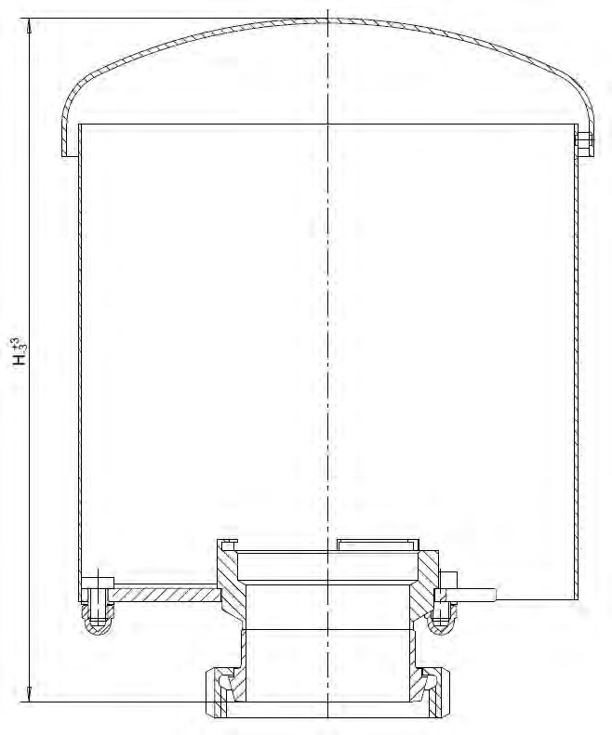
Parts not in contact with the Medium are made by Stainless Steel 304. Jumbo vent housings are delivered with Certificates of the materials.

ORDER CODE AND TECHNICAL EQUIPMENT
Order-no. | No. of Cartridges | Bowl Height | Connection Type  DIN 11851 Liner
 | 01 | 10“ | DN 100 (104x2)
 | 01 | 20“ | DN 100 (104x2)
 | 01 | 30“ | DN 100 (104x2)

